**ORIGIN LAB   
(DIAGNOSTIC LABORATORY MANAGEMENT SYSTEM)**

A Project Report Submitted

in Partial Fulfillment of the Requirement

for the Degree in Master of Computer Applications

By

**Kyrshanlang R. Dkhar**

**University Roll No: SAC MC 15/01**

**Registration No: 2945 of 2012-2013**



Department of Computer Science

St. Anthony’s College, Shillong



**Department of Computer Science**

**St. Anthony’s College, Shillong**

**Affiliated to**

**North Eastern Hill University, Shillong**

**CERTIFICATE**

This is to certify that the project report entitled “***ORIGIN LAB (DIAGNOSTIC LABORATORY MANAGEMENT SYSTEM)***” is an approved work done by

***Mr. Kyrshanlang R. Dkhar*** (Roll No-SAC/MC 15/01) in the partial fulfillment of the requirement for the award of the degree of Master of Computer Application under North Eastern Hill University, Shillong from St. Anthony’s College, Shillong.

*Signature*

**Dr. Anjan Das**

**Director, MCA**

**St. Anthony’s College**

**Shillong – 793001**

**Meghalaya**



**Department of Computer Science**

**St. Anthony’s College, Shillong**

**Affiliated to**

**North Eastern Hill University, Shillong**

**CERTIFICATE**

This is to certify that the Project work titled **‘*ORIGIN LAB (DIAGNOSTIC LABORATORY MANAGEMENT SYSTEM)’*** bonafide work done by ***Mr. Kyrshanlang R. Dkhar, North Eastern Hill University, SACMC 15/01,*** under my guidance during the fifth semester of the course.

*Signature*

**Internal Guide**

*Prof. M. Tham*

Project seminar was held on 4th December, 2017 at

St. Anthony’s College, Shillong

Date: External Examiner

**Acknowledgement**

First and foremost, I would like to thank God for giving me strength and will to complete my project.

I am very grateful to my guide Ma’am Medari Tham, for without her support I would not have completed my project, and also I would like to convey my sincere thanks to Sir Anjan Das, Head of Department, Computer Science and all the Teachers of the Department for their suggestions and feedback which help me developed my mini project in a better way.

Finally, I would like to thank all the members and staff of Origin Diagnostic Laboratory, Shillong for giving me the oppourtunity to work on this project, my friends and my family members for their constant support and love which gave me strength to carry on my project.

**Table of Contents**

Contents

**Introduction** 6

**Client Profile** 7

**Synopsis** 8

**System** **Study** 9

**Proposed** **System** 12

**User** **Requirements** 14

**Feasibility Study** 15

**Data Flow Diagram** 16

**DATA DICTIONARY** 22

**Module Design** 24

**Database Design** 26

Database Design 27

Database Design 28

**Input and Output Screen Design** 34

SOURCE CODE 47

**Future Enhancements** 48

**Conclusion** 49

**Bibliography** 50

# **Introduction**

**A Diagnostic Laboratory** isconcern with performing test on samples to diagnose a person’s wellbeing, samples include blood, urine, sputum, fungal spores and many more. The Test results are then processed and reports are generated.

The Origin Diagnostic Laboratory, Shillong is located in Jaiaw Langsning has several departments and each department has a set of tests that are performed.

This mini project is a client based mini project for Origin Diagnostic Laboratory, Shillong.

The mini project is an web application that will help in automating the process of generating reports for the patients of the organization and standardizing the Laboratory Normal Range Values for specific Tests.

# **Client Profile**

The Origin Diagnostic Laboratory Center was started in 2017 with the objective of providing quality and timely service to its clients, the Origin Diagnostic Laboratory Center has incorporated and invested in some of the latest technological equipment to meet the needs of the time.

With a team of young and committed professionals at the helm of management, the future of the center is promising.

The Organization currently has One(1) Laboratory, Three(3) Collection Centers and Twelve(12) working staffs including a Medical Consultant, Lab Technician, and Data Entry Operator.

The Laboratory has several Departments and each Department has a set of Tests that are performed.

The list of Departments and Tests are provided in the Existing System study.

# **Synopsis**

**Project Description**

The proposed System is based on the requirements of the Management Team from Origin Diagnostic Laboratory, an application is to be developed that will help in automating the process of generating reports for it’s patients, standardizing the Laboratory Normal Range Values for different Test and increase the work efficiency of the Laboratory.

The Application will be a web based application and will include the following features:

1. Allow the Administrator to Manage Departments and Tests.
2. Provide the Administrators to create and manage Patient’s Details, Patient’s Test Reports and Bills.
3. Allow the Administrator to View Monthly Reports on the total number of tests completed, total number of positive test cases and total number of bills settled.
4. Standardized the Normal Range of specific Tests of The Laboratory.
5. Provide the Average Result Range, Highest Range and Lowest Range of specific Tests of the Laboratory.

**Language used**

* PHP, HTML, JavaScript, CSS.

**Database**

* MySQL

# **System** **Study**

**Existing System**

At Origin Diagnostic Center, Samples are collected from the Collection Center.

Tests are performed in the Laboratory and the results of these tests are noted down by the Lab Technician and Staff of the Laboratory.

The Results are confirmed by the medical consultant, entered into a file by a Data Entry Operator and Reports are then generated manually and printed, each report must be manually generated for different types of Tests and the task is an exhaustive time consuming task.

Samples collected include Blood Samples, Urine Samples, Sputum, Stool samples, Throat swabs and Fungal spores.

Test are done either manually or on the spot using Portable Devices or automatically with the help of automated machines (e.g Biochemistry Analyzer, Electrolyte Automated Analyzer, Urine Analyzer, Immunoflorescence Analyzer).

Tests Performed are of three types : Normal Test, Culture Test and Special Tests.

**Normal Tests** are tests that examine and test body tissues and fluids that have a single result within a normal range.

**Culture Tests** are used to diagnose infection and to identify the bacteria or yeast causing the infection. It may be done in conjunction with susceptibility testing to determine which antibiotics will inhibit the growth of the microbe causing the infection.

**Special Test** are mostly serological tests for determining Typhoid fever, Dengue fever etc, by looking at the titre, which is in the form N:M example 1:160.

**Departments & Tests Performed by each department:**

* + **Biochemistry(Normal Tests)** – Blood Sugar, Thyroid Test, Liver Function Test, Kidney Function Test, Diabetic Profile, more…
  + **Microbiology(Culture Tests)** – Blood Culture, Stool Culture, Urine Culture, Respiratory Culture, more…
  + **Serology(Special Tests)** – Widal Test, Dengue, Malaria, ABO Group
  + **Hematology(Normal Tests)** – WBC, LYM%, MID%, GRAN%, RBC, HGB, more…

|  |  |  |
| --- | --- | --- |
| **Department (Test Group)** | **TEST** | **Unit and Sample Result Range** |
| BioChemistry (Thyroid Function) | Thyroid (T3) | 0.92-2.33 nmol/L |
| Thyroid (T4) | 60-120 nmol/L |
| **BioChemistry** | Amylase | Up to 90 U/L |
| Lipase | Up to 60 IU/L |
| **BioChemistry**  (Liver Function Test) | SGOT (AST) | 0-40 IU/L |
| SGPT (ALT) | 5-40 IU/L |
| **Hematology** | WBC | 3.5-9.5 *10∧9/L |
| LYM % | 20.0-50.0 % |
| MID % | 3.0-10.0 % |
| GRAN % | 40.0-75.0 % |
| LYM # | 1.1-3.2 *10^9/L |
| MID# | 0.1-0.6 *10^9/L |
| **Serelogy** | Widal (O,H,AH,BH) | 1:120 |
| Weil Felix (OX2,OX19,OXK) | 1:60 |
| Dengue (IgG,IgM,NS1 Ag) | 1:120 |
| Scrub Typhus(IgG,IgM,IgA) | 1:80 |
| **Microbiology** | Blood Culture | Test Antibiotics Sensitivity :Result can be **Sensitive/Intermediate/Resistance** to The Sample. |
| Urine Culture |
| Stool Culture |

**Table:** List of Tests along with Their Unit and Sample Result/ Result Range

**Drawbacks of the Exsiting System**

1. Report and Bill generation are done manually.
2. Keeping records of patients, tests and reports are difficult.
3. Computing Average/Lowest/Highest Range of a test is exhaustive and time consuming.
4. Computing Standardized Normal Range for each test is difficult.

Figure 1 Sample Report

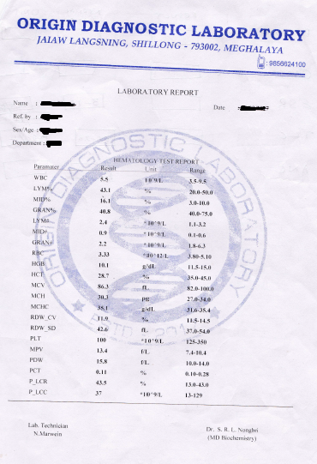

# **Proposed** **System**

The Proposed System will be an application that will help in automating the process of generating reports for its patients, standardizing the Laboratory Normal Range Values for different Test and increase the work efficiency of the Laboratory.

The Proposed system will have two types of users the Administrator user and Staff user.

The Staff user will be able to manage patient details, generate reports for any test that belongs to a particular department, view and print the Reports and Bills of any patient and he will also be able to view the monthly report of the organization on the total number of tests completed, total number of positive test cases and total number of bills settled.

The Administrator user will have all the priveliges that the Staff user has and he will also be able to Manage Departments, Tests and Calculate the Standard Normal Range of a specific Test.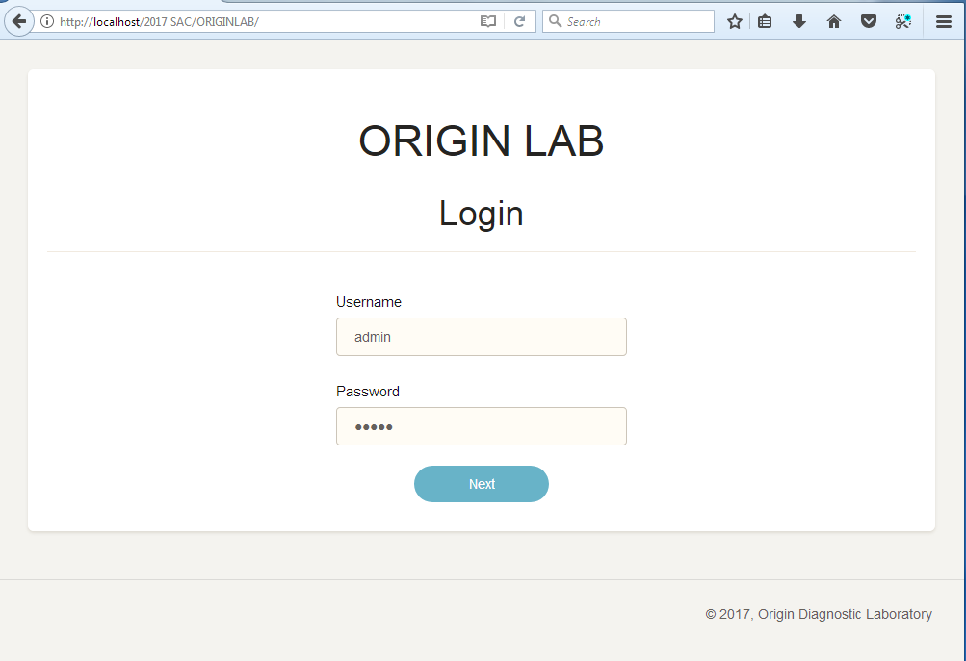

Picture: Proposed System Screenshot

**Features**

* **Departments and Tests Managment**
  + The Administrator will have his own account which he could log in. Once logged in he can Manage Departments and Tests of each Department.
* **Patient Details :**
  + - The Administrator and the Staff of the Laboratory can Manage Patient Details, i.e add,edit and remove patient details.
* **Test Reports Generator**
  + The user of the system will be able to generate reports of a particular patient whose test has been completed by entering the results of the test into the system, the user will also be able to print the report generated.
* **Monthly Report Generator**
  + - This feature will provide the users of the system with monthly overview of the total number of tests completed, total number of positive test cases and total number of bills settled for the current month.
* **Stadardized Normal Range**
  + Standardized the Normal Range of a particular Normal Tests of a department, this is done by specifying the start and end date for calculating the Standard Values, finding the mean, standard deviation from the mean of all the test results for that particular period and
  + To provide the Highest Range and Lowest Range of particular Normal Tests of the deparment.

# **User** **Requirements**

**Software Requirements**

1. Web Browser, WampServer.
2. Window 7/8/10.

**Hardware Requirements**

1. Intel Dual Core processor 2.4 GHZ or above.

2. RAM: 1 GB or above.

3. Hard Disk Space: 1 GB or above.

4. Printer for printing reports.

5. Uninterrupted Power Supply to ensure a constant access of data

# **Feasibility Study**

“Feasibility is defined as the practical extent to which a project can be performed successfully. To evaluate feasibility, a feasibility study is performed, which determines whether the solution considered to accomplish the requirements is practical and workable in the software. The objective of the feasibility study is to establish the reasons for developing the software that is acceptable to users, adaptable to change and conformable to established standards. Various other objectives of feasibility study are listed below.”

**Technical Feasibility**

* For the mini-project to be developed successfully it requires knowledge of web technology and database.
* For the Organization, a system that meets the minimum Hardware requirements is available and the Administrator and Staffs have the technical knowledge of using the Application by entering results through Mouse clicks and Form inputs.
* Inferring all these, the mini-project is technically feasible to undergo further development.

**Operational Feasibility**

* The requirements of the proposed system demands that it should provide at least the basic functionalities of report and bill generation and auto-standardization of Normal Range of Normal Tests, which will increase the efficiency of the existing system and automate the manual work process of the Diagnostic Laboratory.
* A User Friendly Environment will be provided to the User of the System in order to automate the work, hence it will be operationally feasible.

**Economical Feasibility**

* The Mini-Project will be an offline system, the cost of the system would be to acquire a Computer that meets the minimum requirements to run the Software and a Printer, Since the Organization already have a Computer and a Printer to do their work, no further Hardware cost is required.
* Hence this mini-project is economically feasible.

# **Data Flow Diagram**

**CONTEXT LEVEL DATA FLOW DIAGRAM**

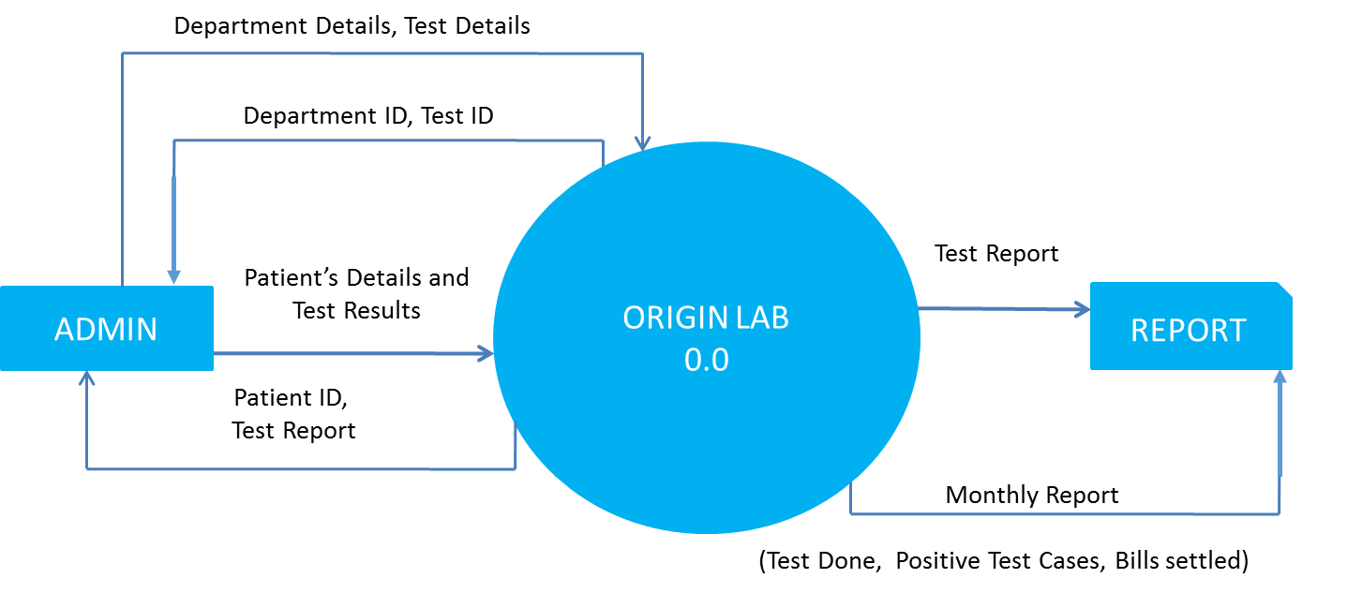

**LEVEL 1 DATA FLOW DIAGRAM**

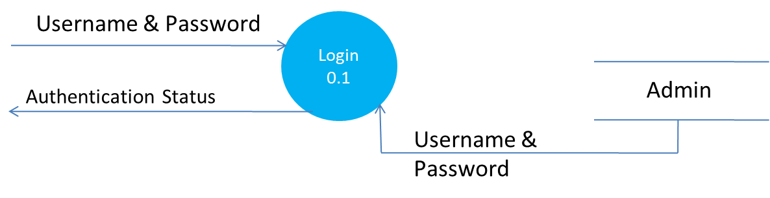

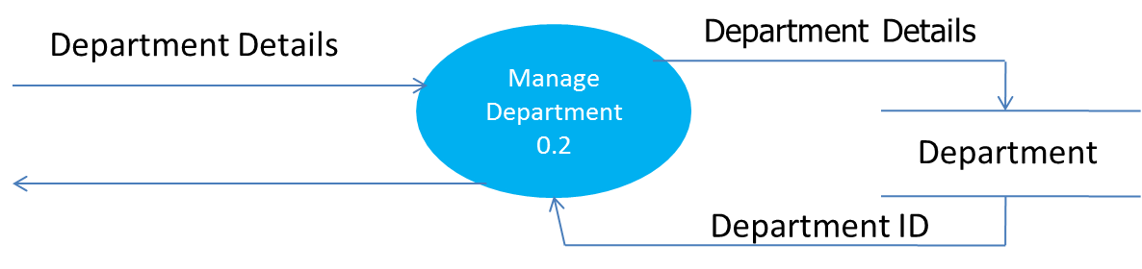

Department ID

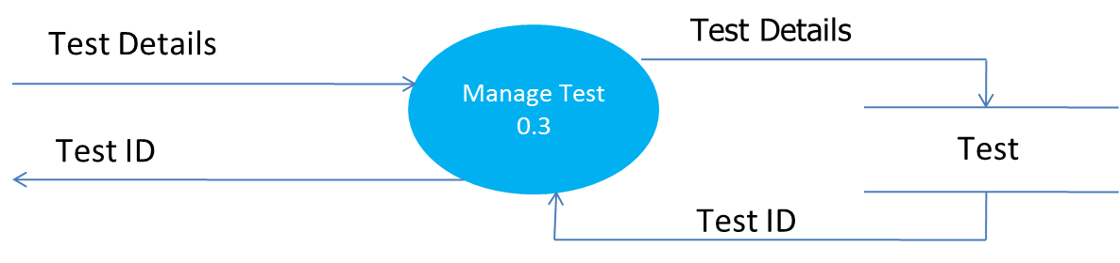

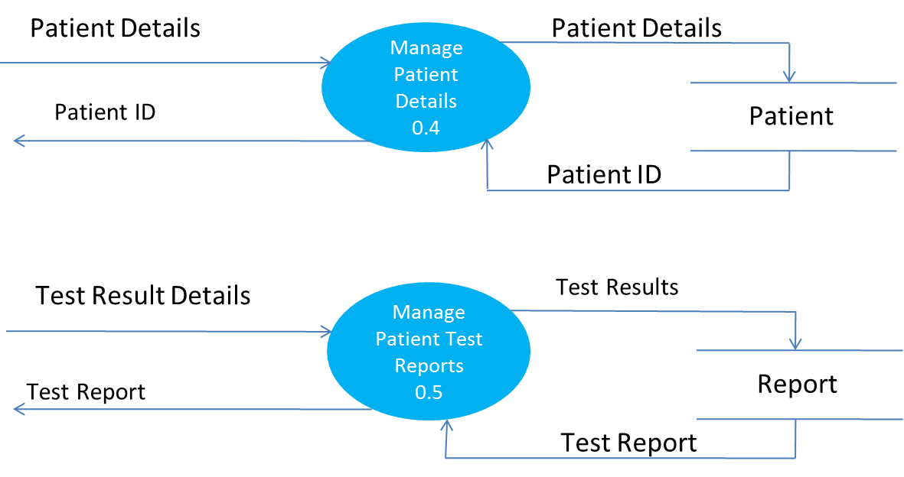

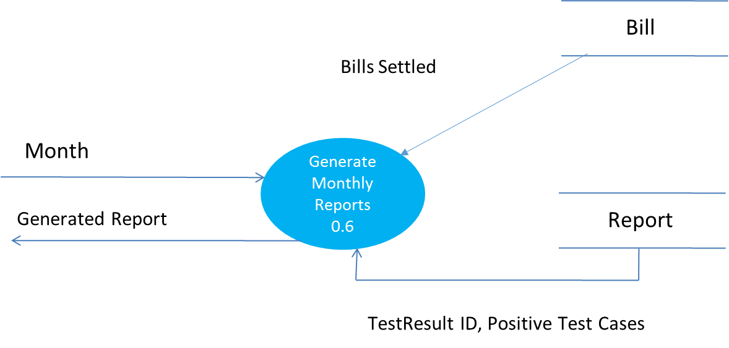

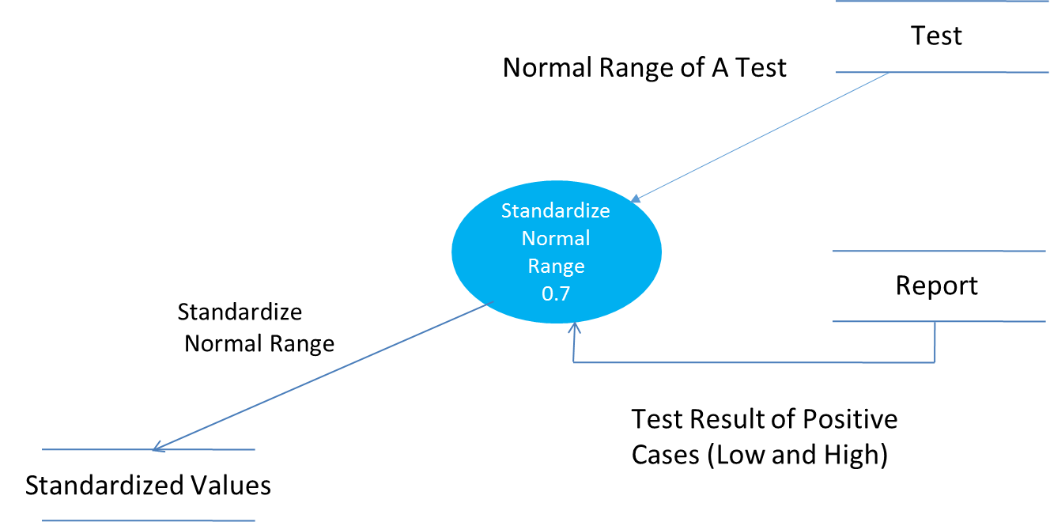

**LEVEL 2 DATA FLOW DIAGRAM**

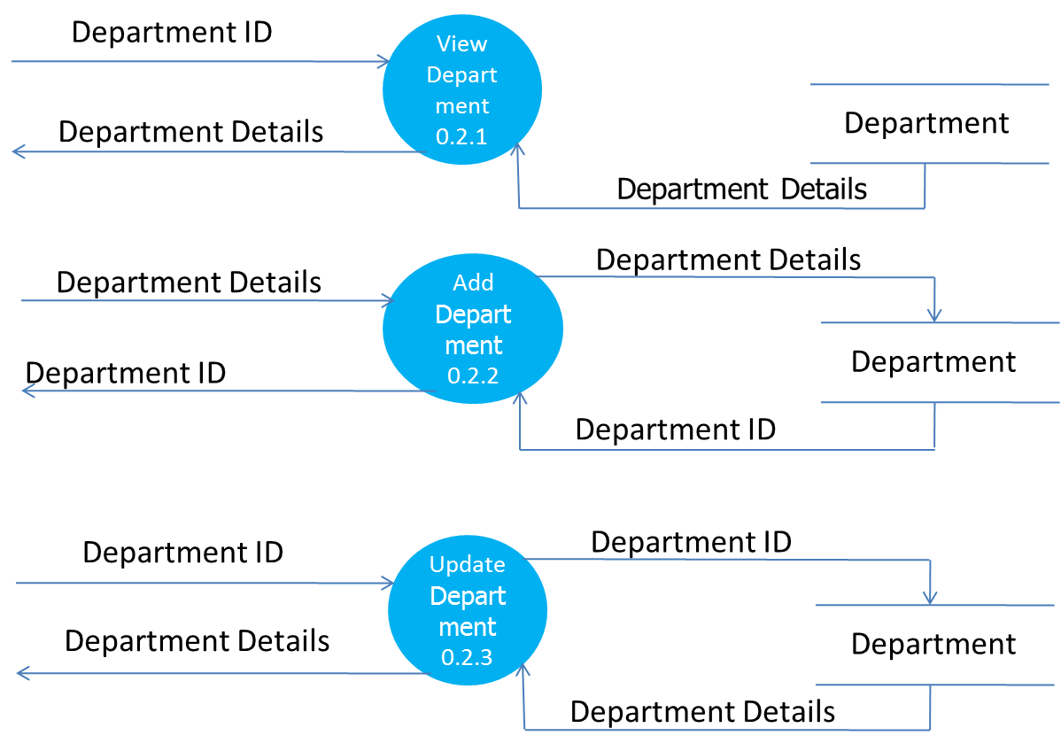

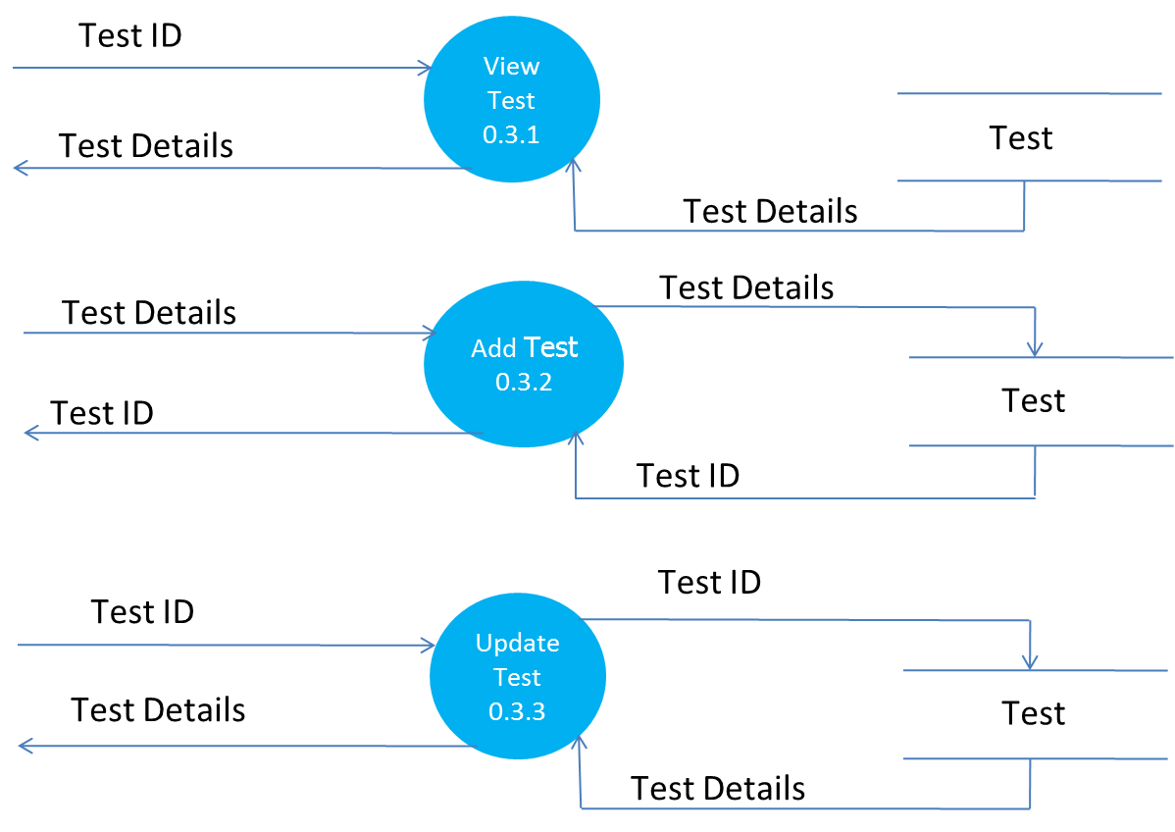

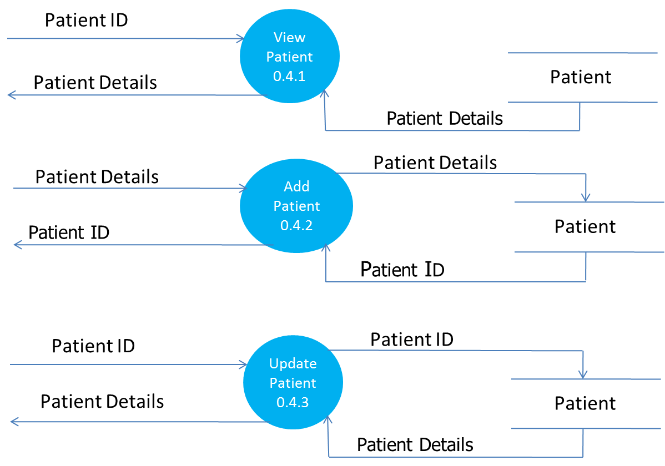

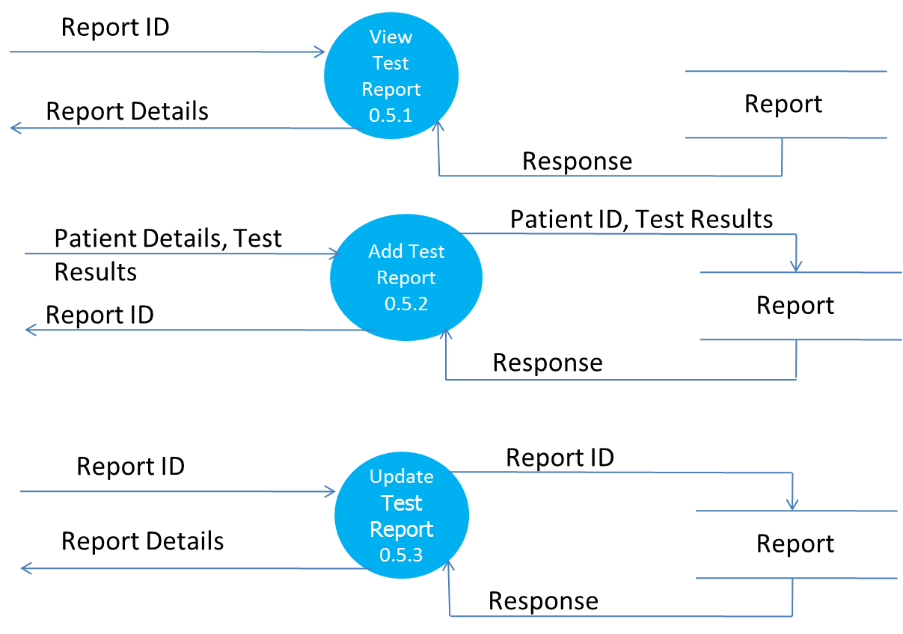

**LEVEL 3 DATA FLOW DIAGRAM**

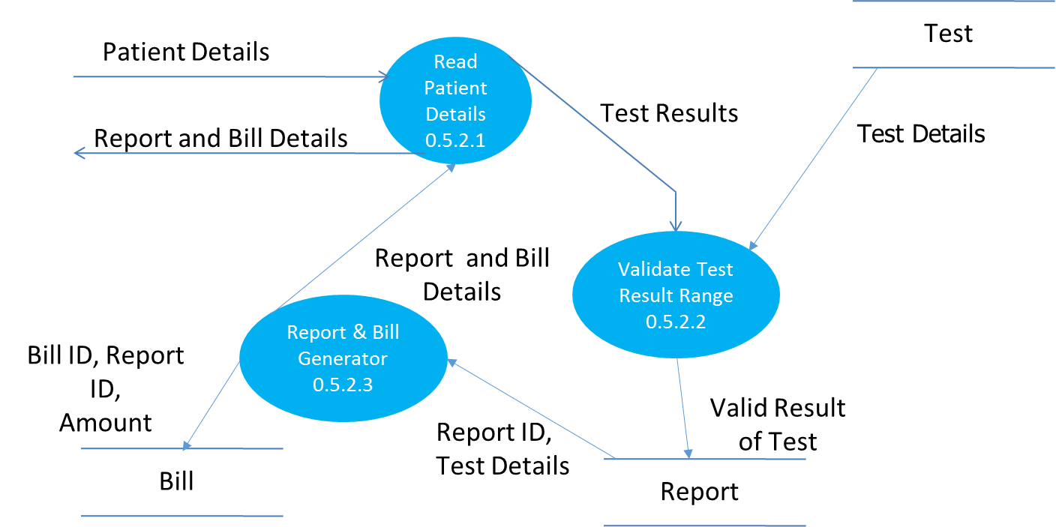

# **DATA DICTIONARY**

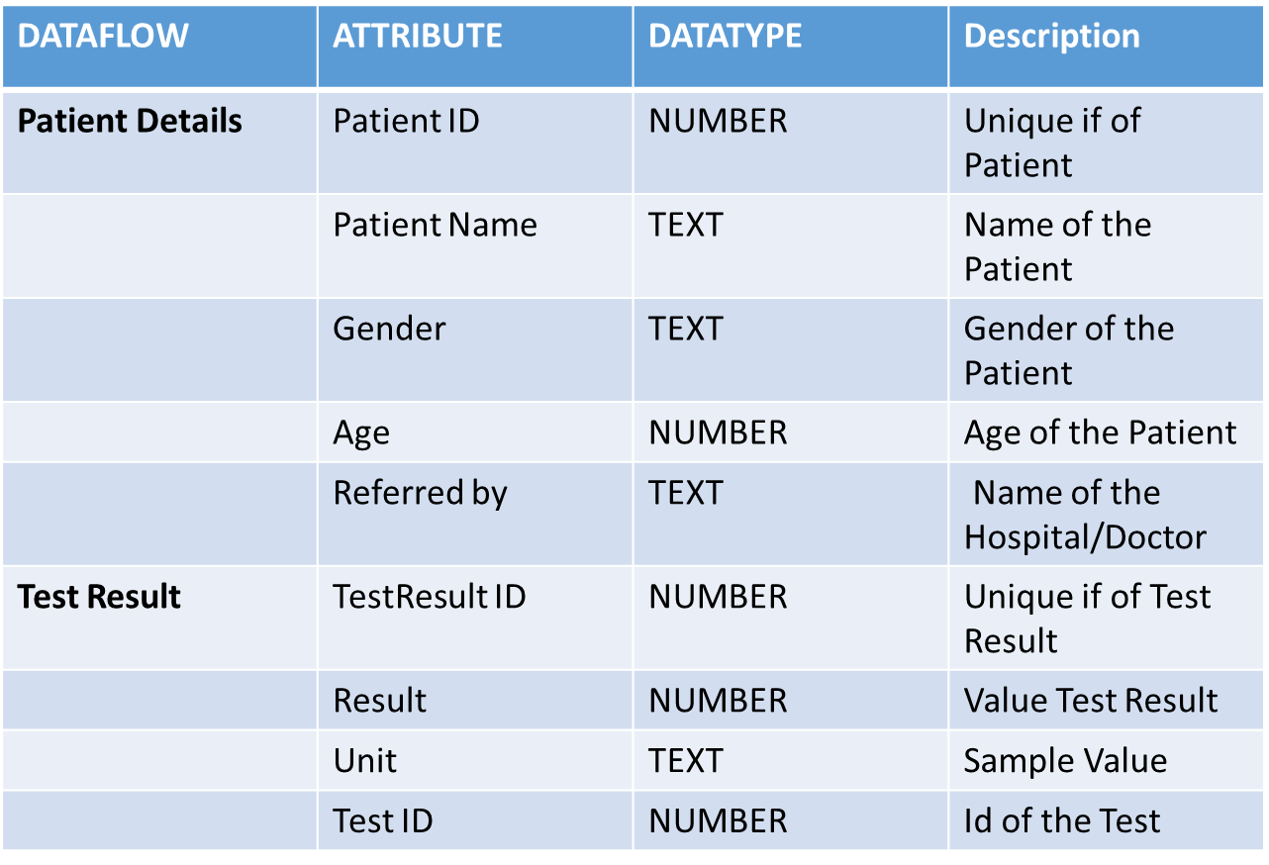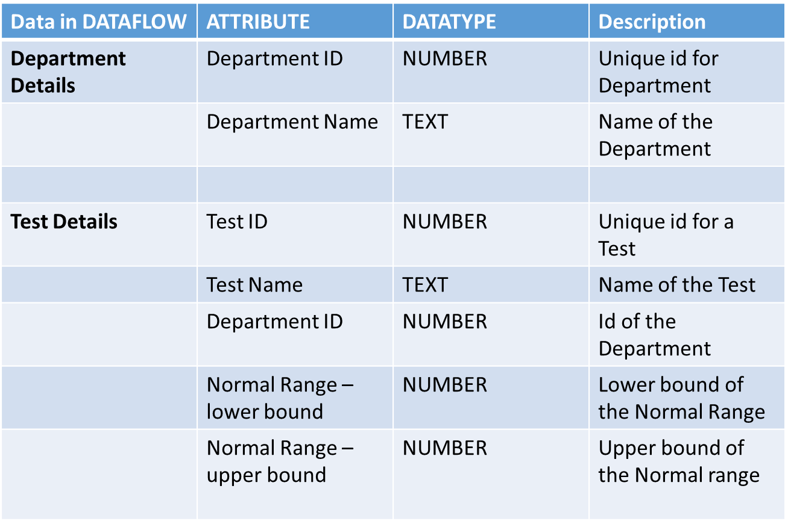

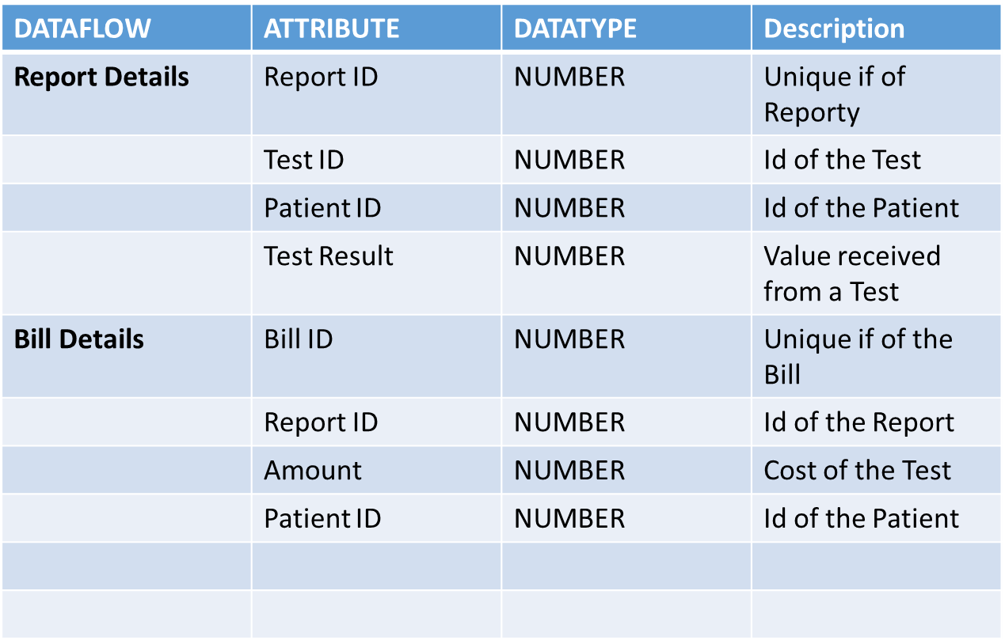

# **Module Design**

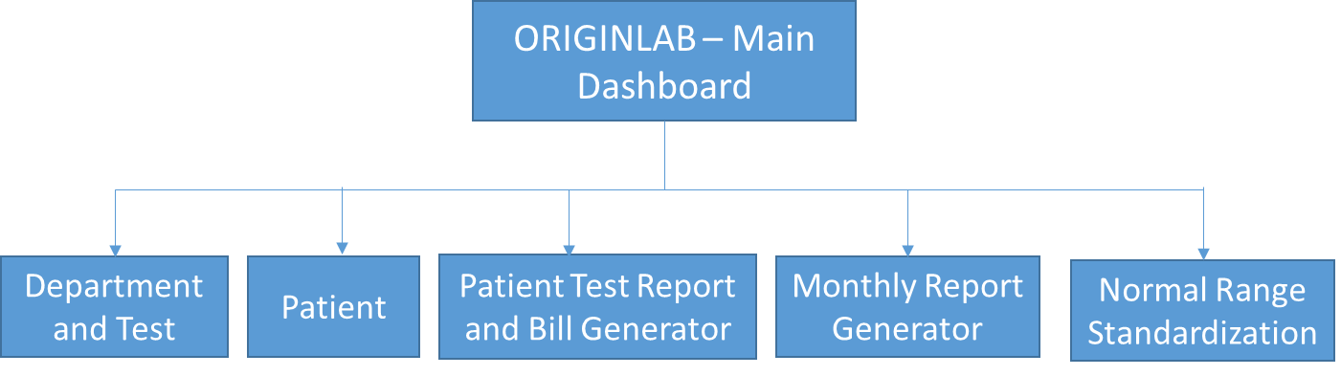

**1) Main Dashboard Module**

* + This Module is the main module that the user sees when logged in.
  + This Module Provides the user with options to interact with the different modules.
  + It also provide a short Over view of the System; i.e Number of Departments, Tests, Patients, Reports and it will also displays the output provided by the “Monthly Report Generator Module” in a text format.

**2) Department And Test Management Module**

* + This Module can be further divided into two smaller modules in which the administrator of the system can manage the departments in the system and the test that each department performs.
  + The Department Module allows the admin to view, create, edit and remove departments.
  + The Test Module allows the admin to view, create, edit and remove tests of each department.

**3) Patient Module**

* + This Module allows the user of the system to view a patient’s details, add a new patient, edit a patient and remove an existing patient.
  + It can also allow the user to find/search for an existing patient.

**4) Patient’s Test Report and Bill Generator Module**

* + This Module allows the user to generate Test Report on the various tests performed by the laboratory for a patient. It will generate the bill of the Test Report and also allow the user of the system to Print the Report and The Bill of a particular patient.
  + Additional features of this module is that test results will be validated during the result entry by the user into the system, and only values that are confirmed will be stored, any abnormal value will be notified to the user.

**5) Normal Range Standardization Module**

* + This Module will make the workflow of finding and calculating the Standard Normal Range of a particular Test after a period of several months and it will provide the user with the average normal range, highest and lowest result value of a particular test.
  + These new standard normal range can then be updated to the existing normal range.

# **Database Design**

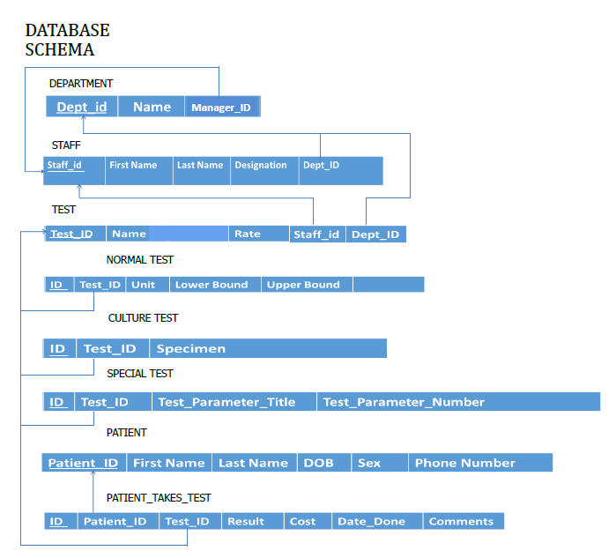

# Database Design

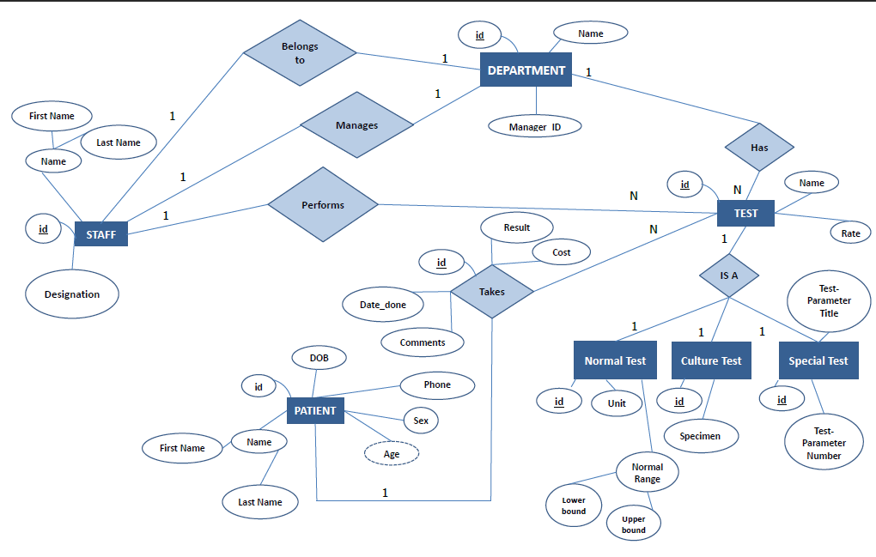Entity Relationship Diagram

# Database Design

Database Tables

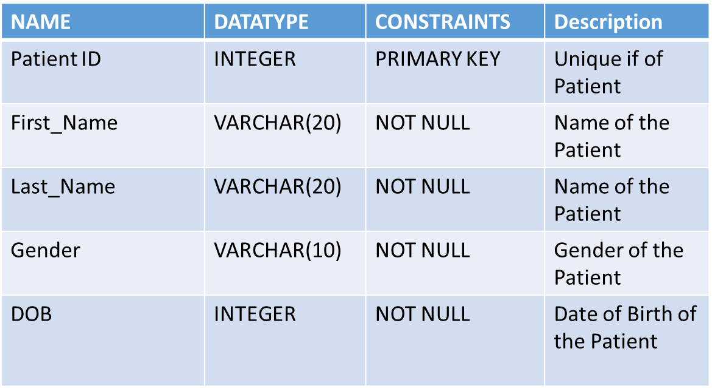PATIENT TABLE

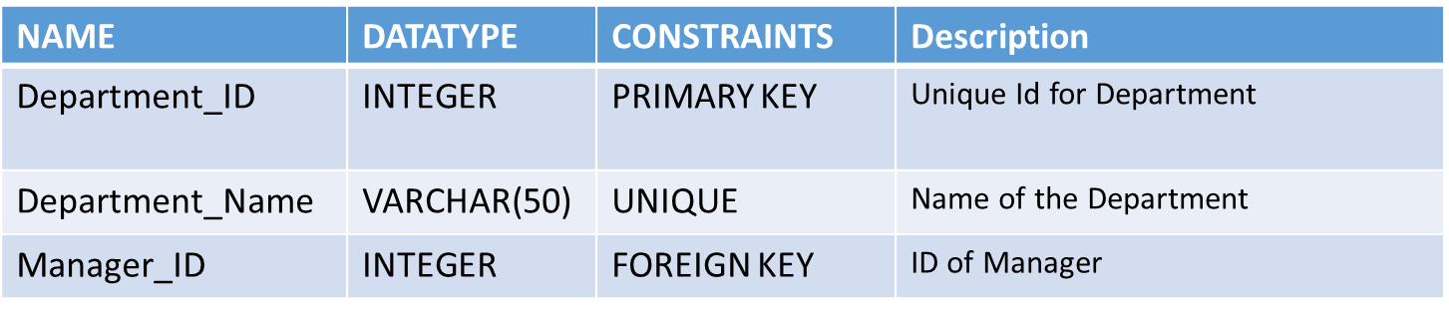DEPARTMENT TABLE

TEST TABLE

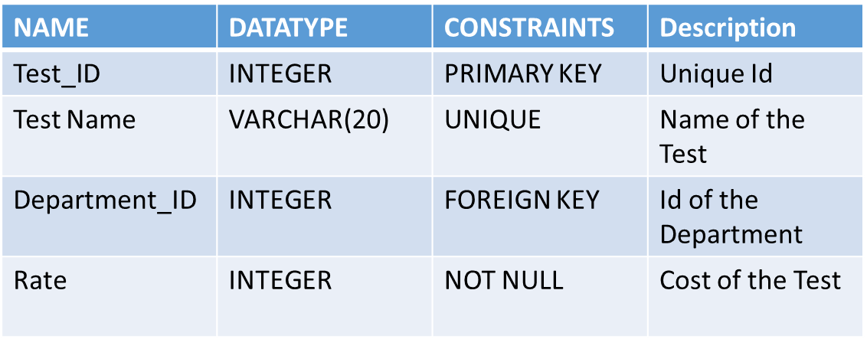

NORMAL _TEST TABLE

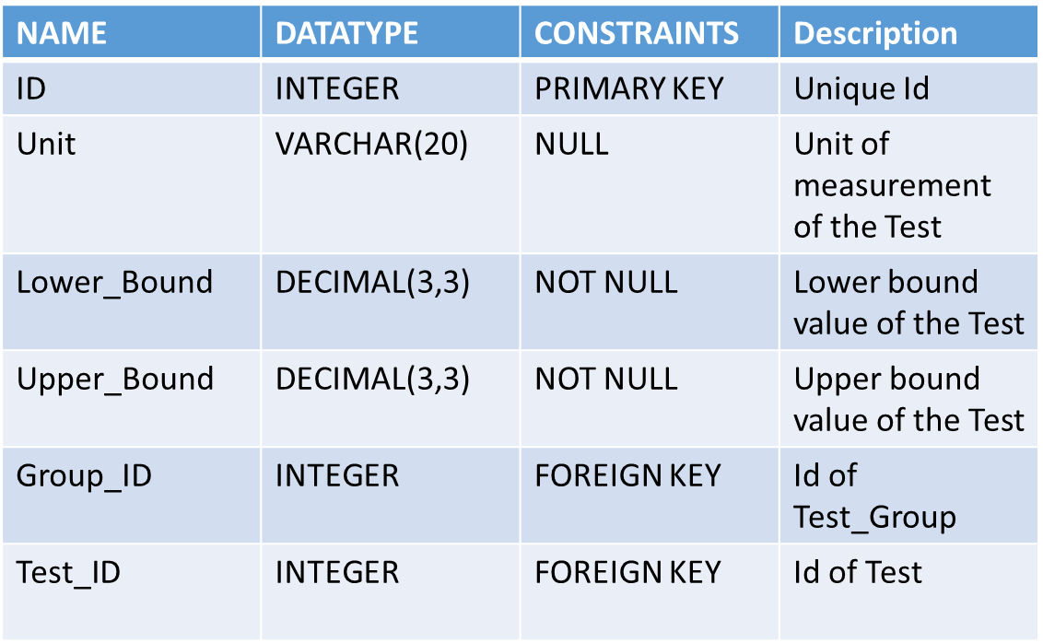

CULTURE_TEST TABLE

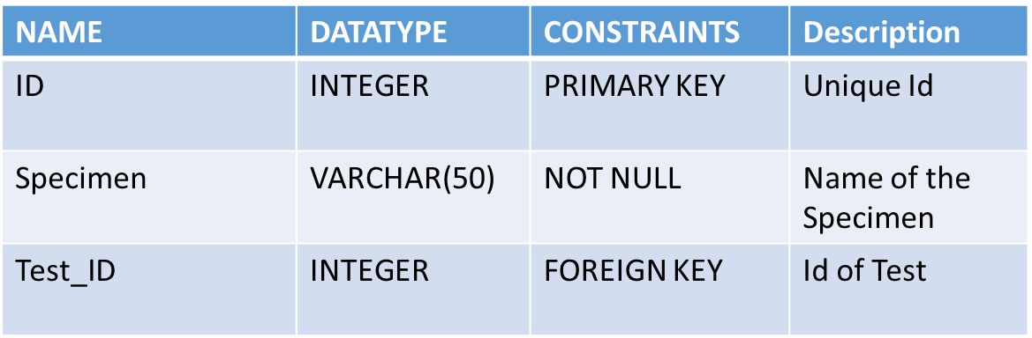

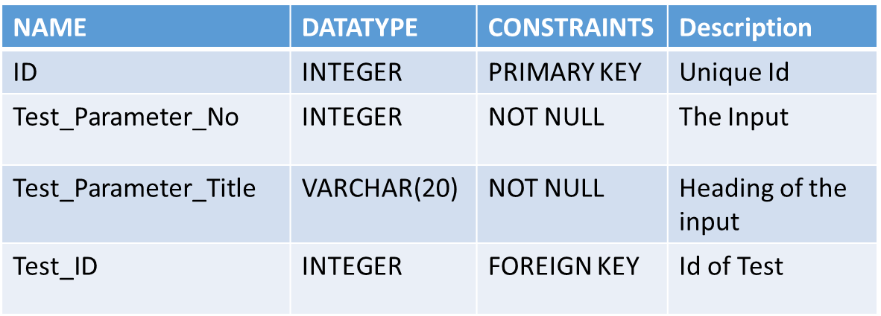SPECIAL_TEST TABLE

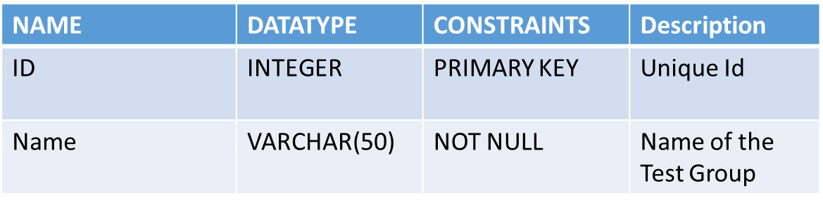TEST_GROUP TABLE

NORMAL_TEST_RESULT TABLE

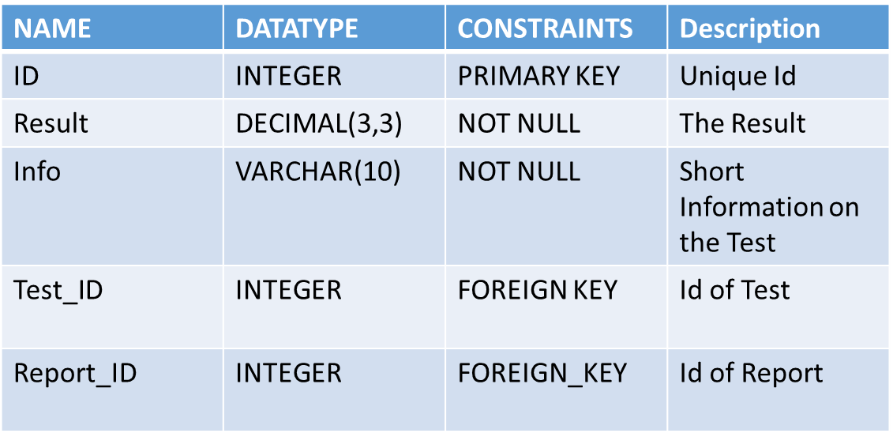

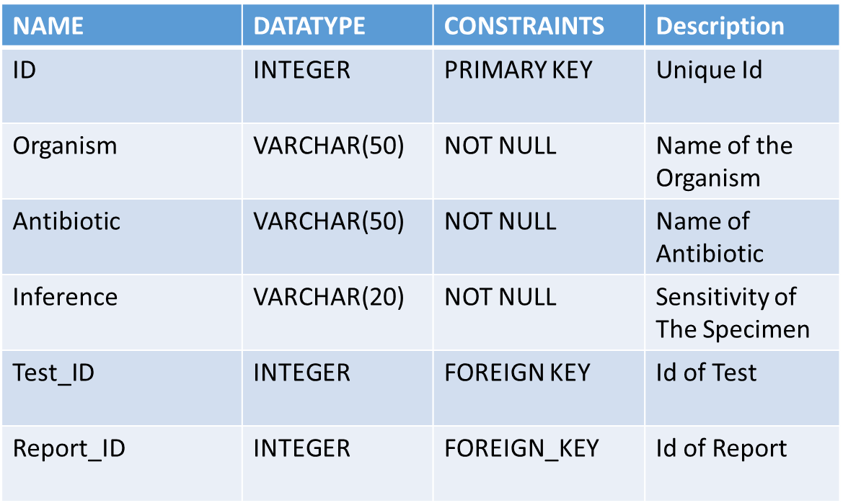CULTURE_TEST_RESULT TABLE

SPECIAL_TEST_RESULT TABLE

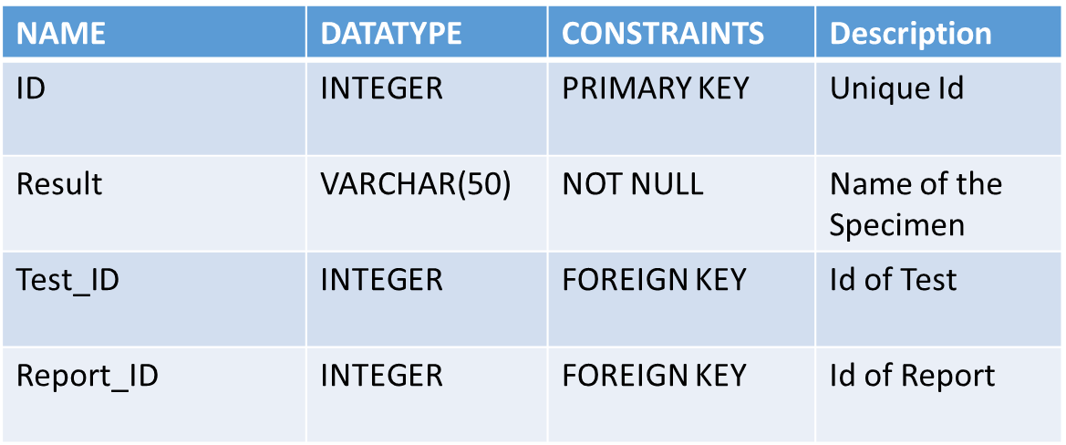

REPORT_OF_PATIENT_TAKES_TEST TABLE

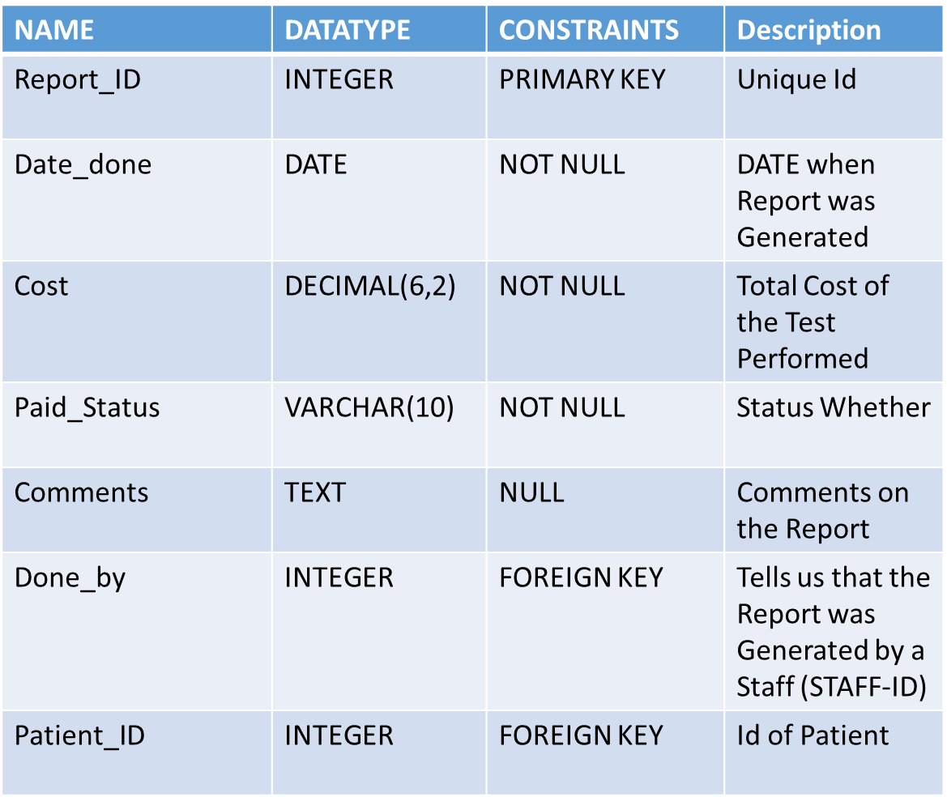

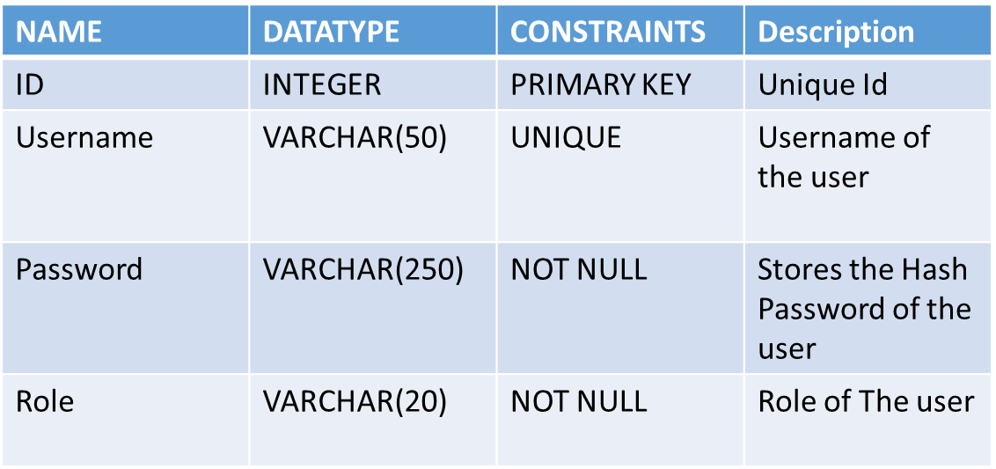USER TABLE

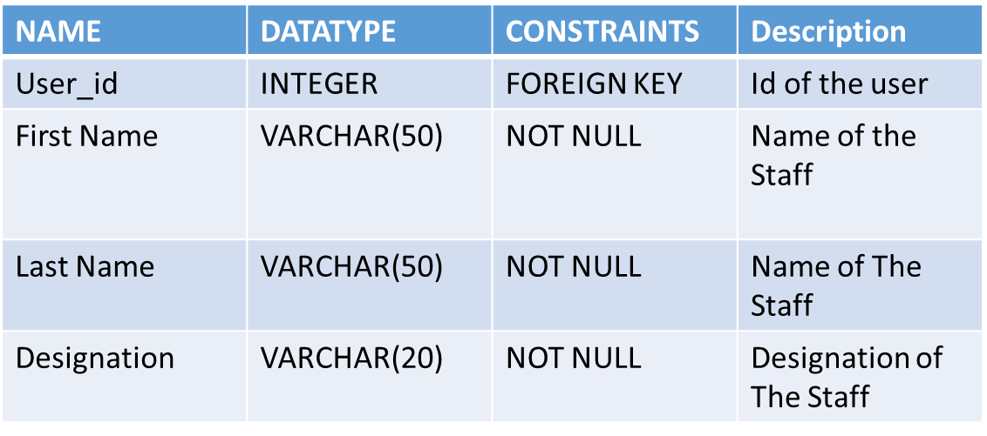STAFF TABLE

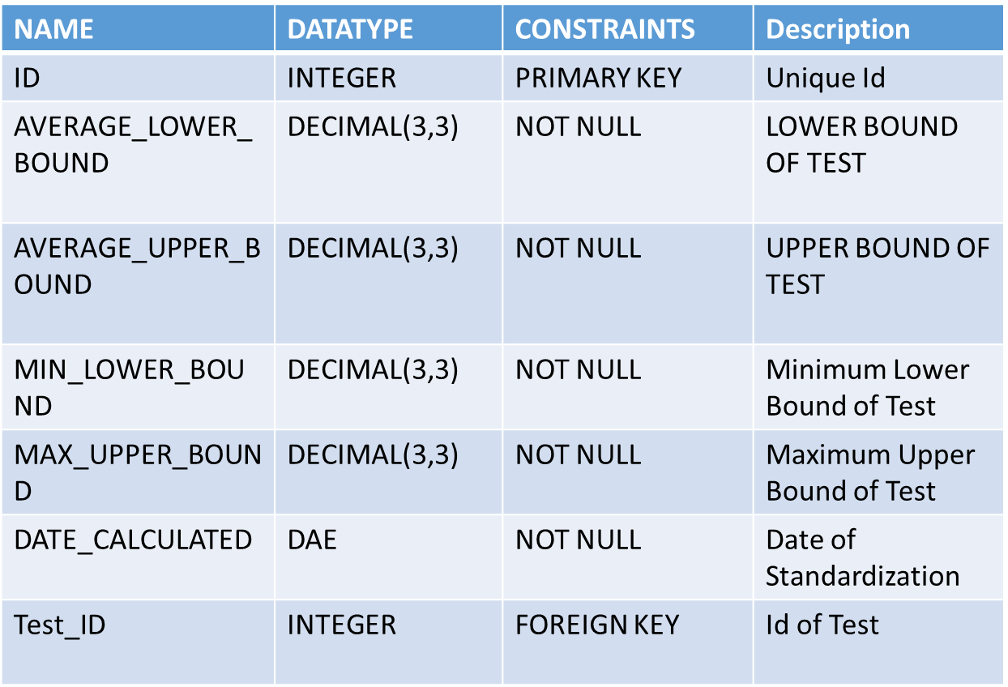STANDARD_NORMAL_RANGE TABLE

# **Input and Output Screen Design**

The Interface for the mini project is build on the Bootstrap CSS framework and based on the free paper-dashboard theme by Creative Tim.

Bootstrap is an open source toolkit for developing with HTML, CSS, and JS. It is a framework for building responsive, mobile-first sites.

**Input And Output Screens with Testing data and Results**

1. Login Screen



2. Dashboard (Staff View )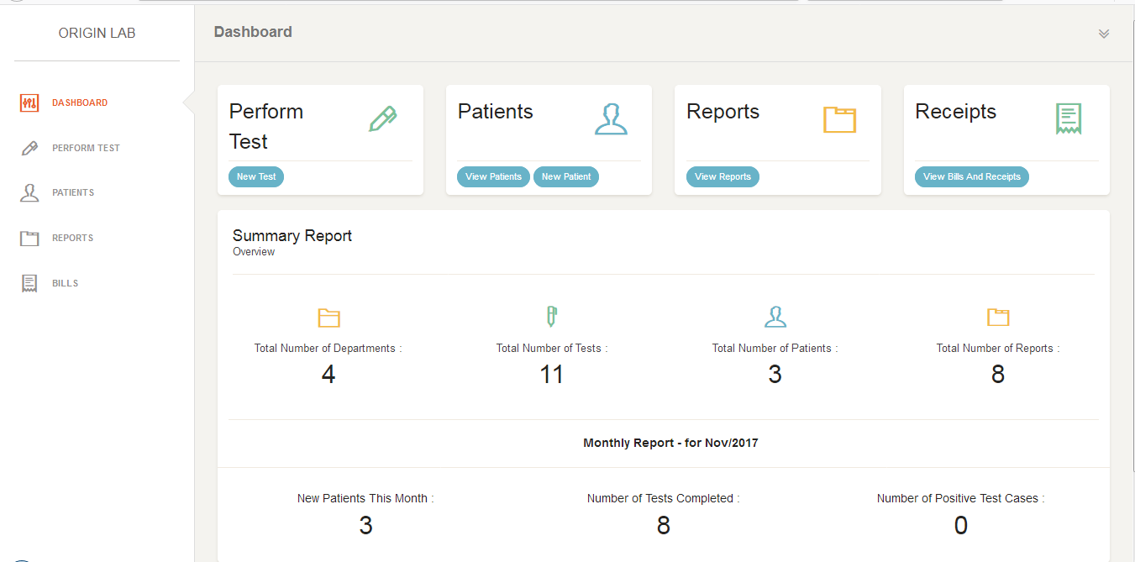

3. Dashboard (Admin View )

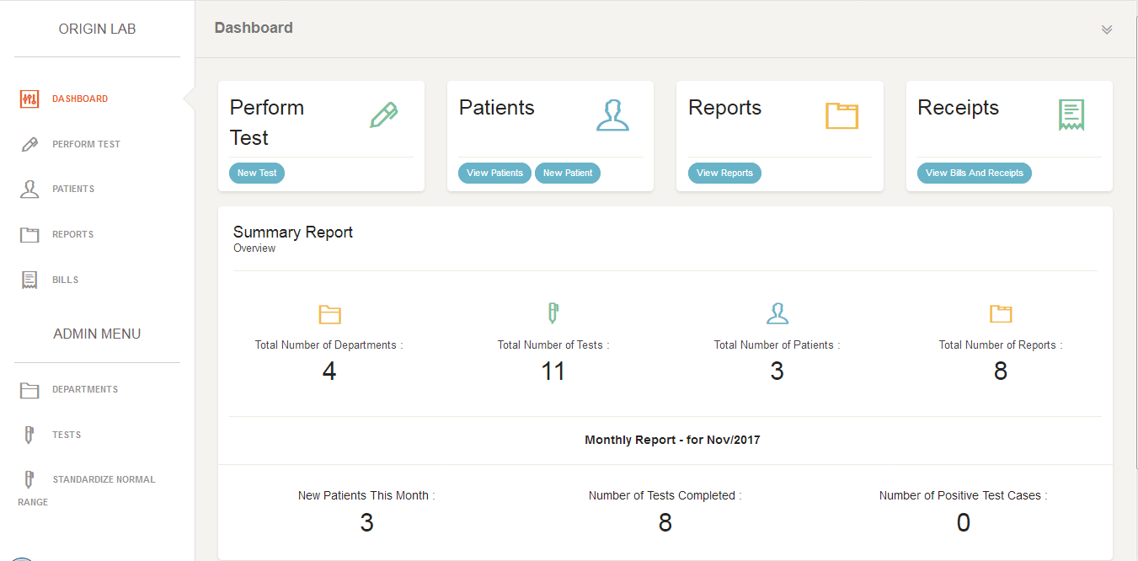

4. Create a New Department

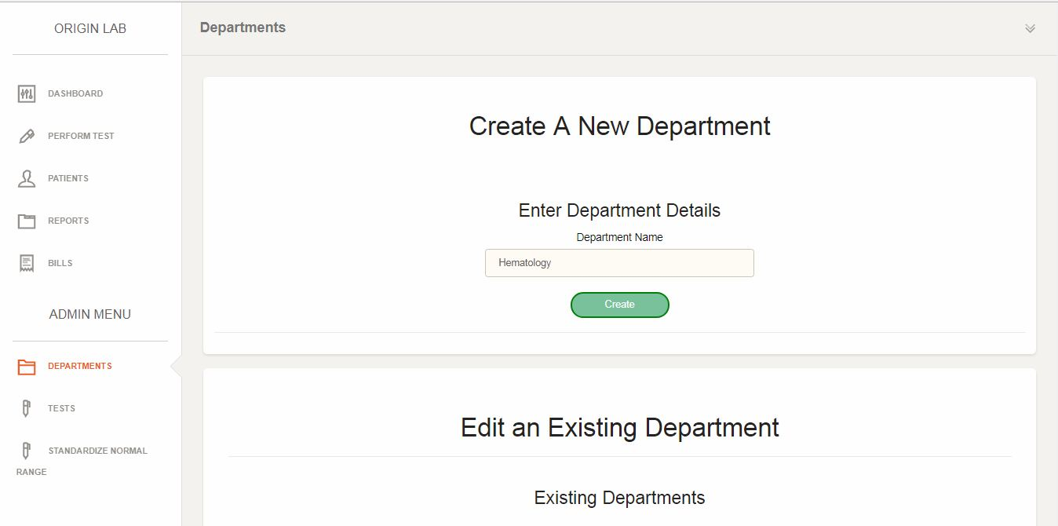

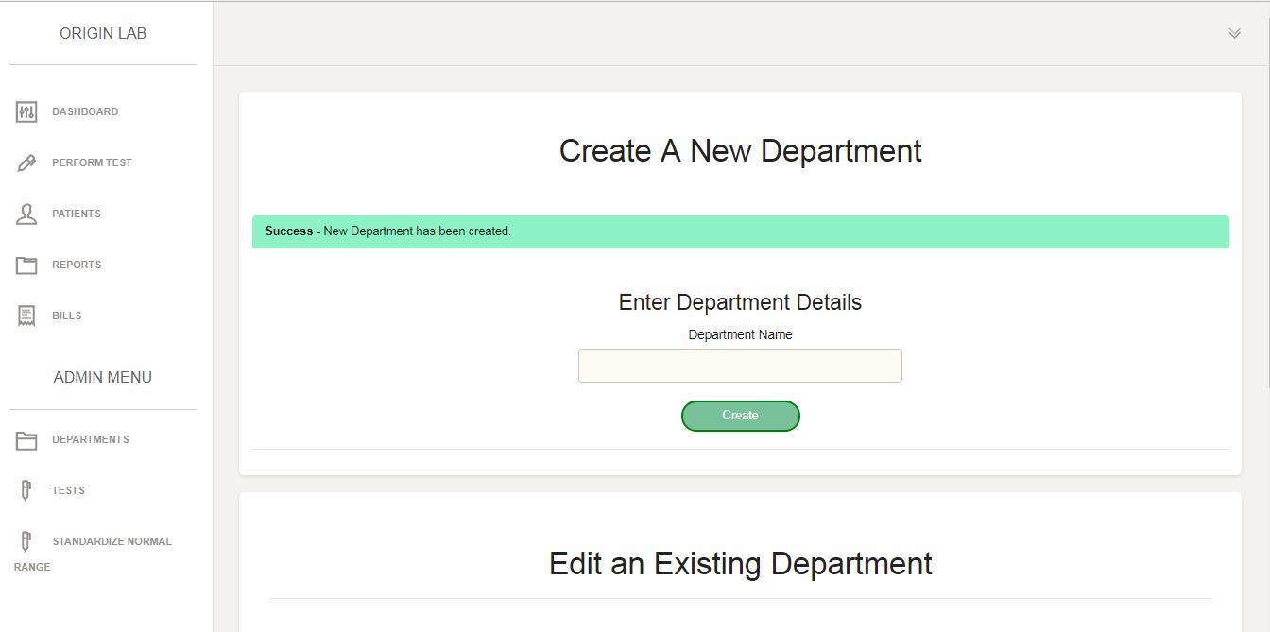

5. Remove Department

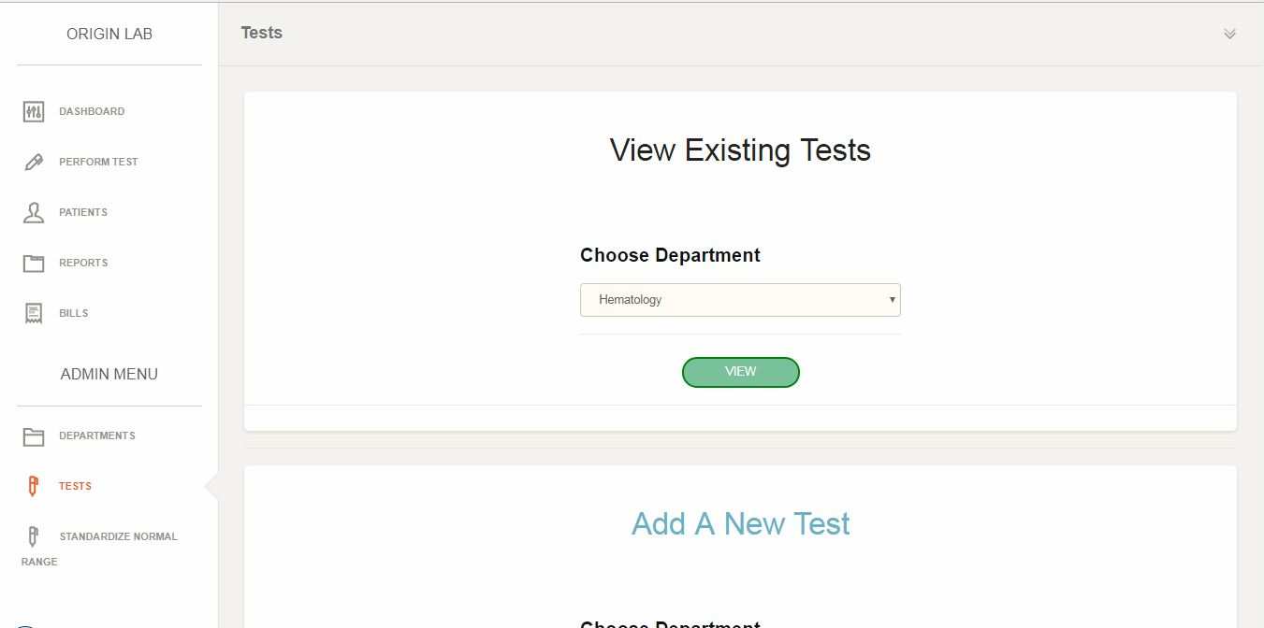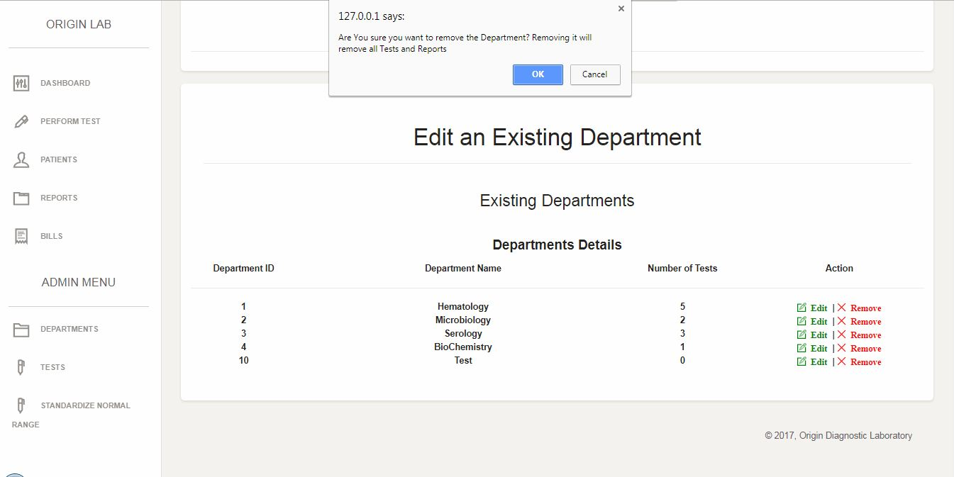

6. View Tests of a Department

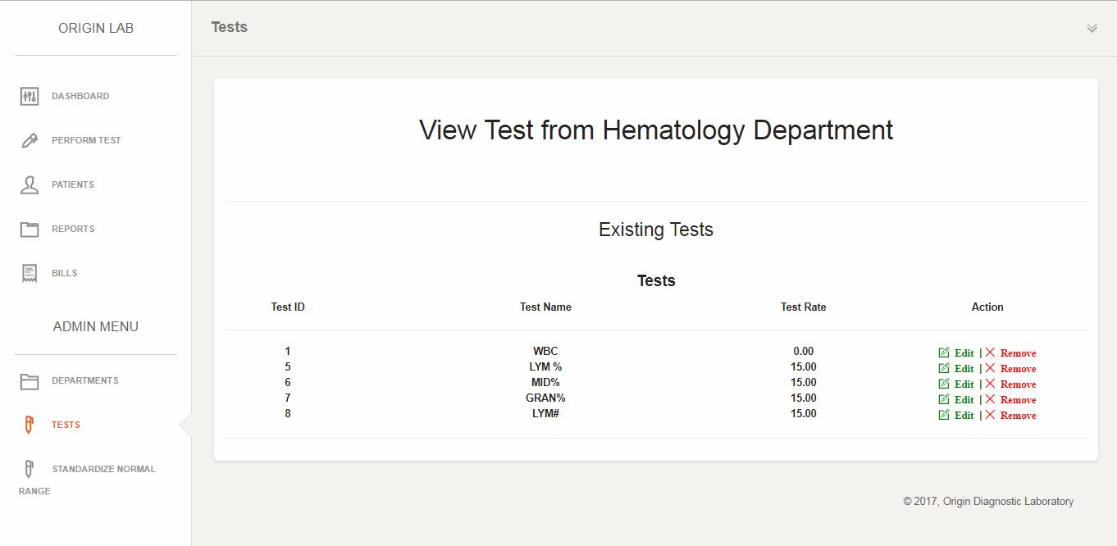

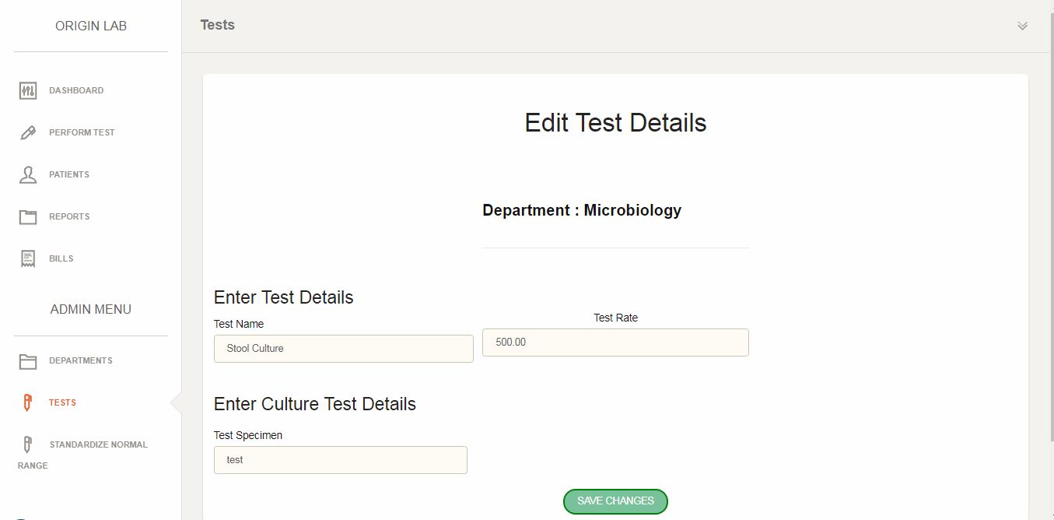7. Edit Test Details

8. Add a New Test (Normal Test)

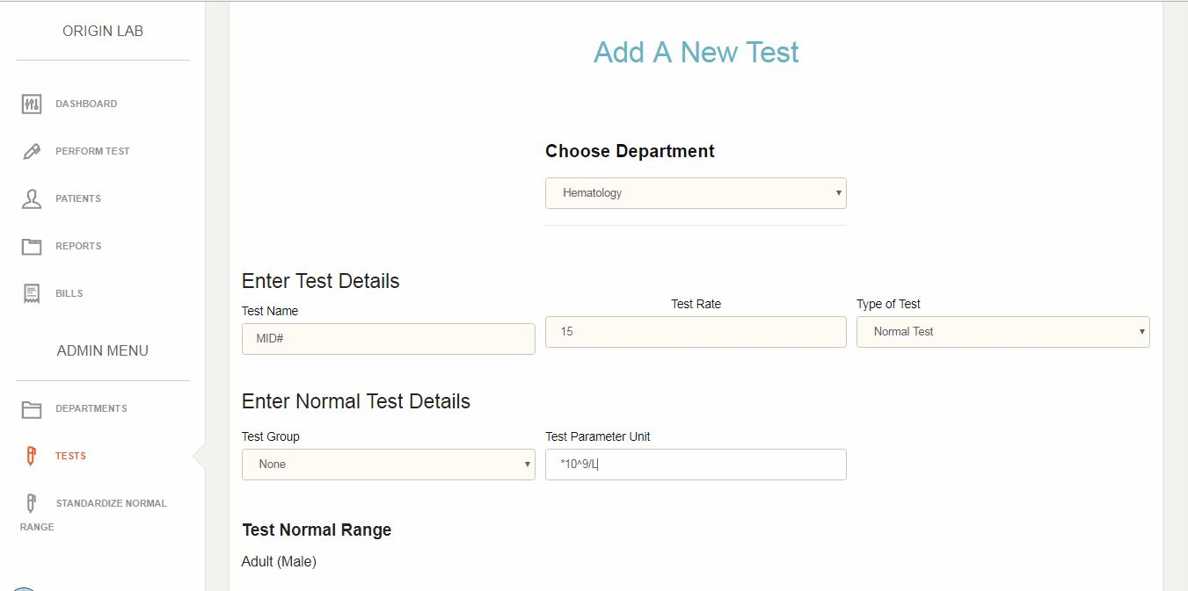

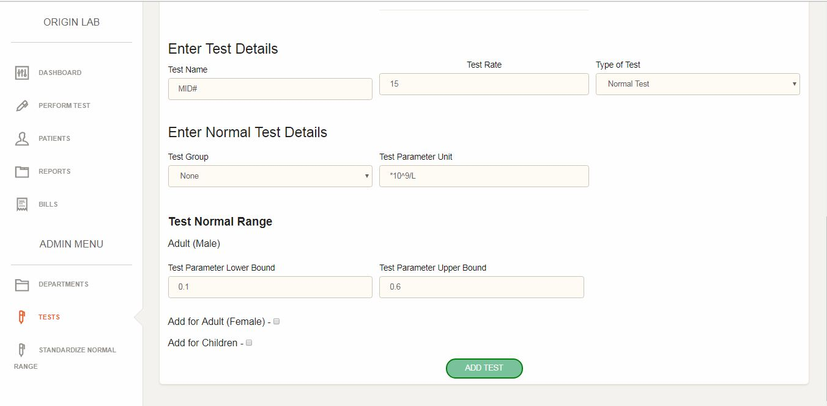

9. Add a New Test (Culture Test)

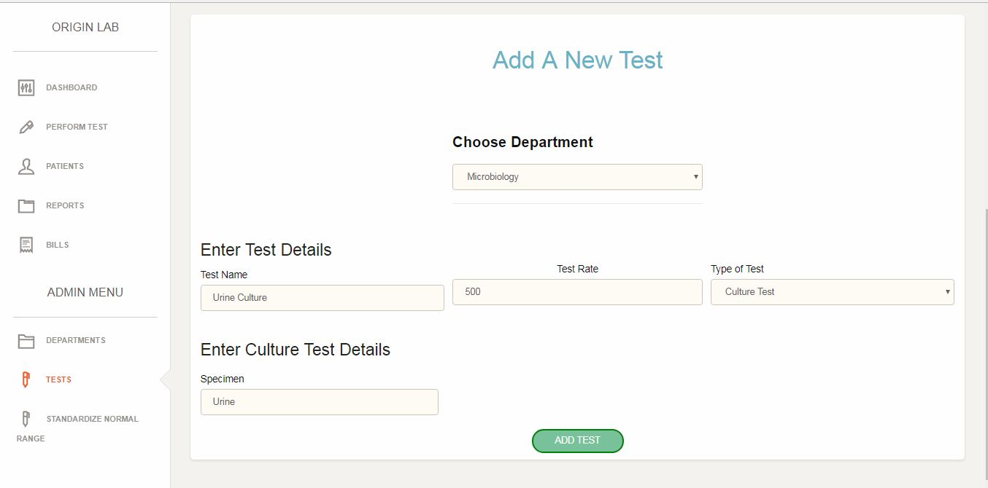

10. Add a New Test (Special Test)

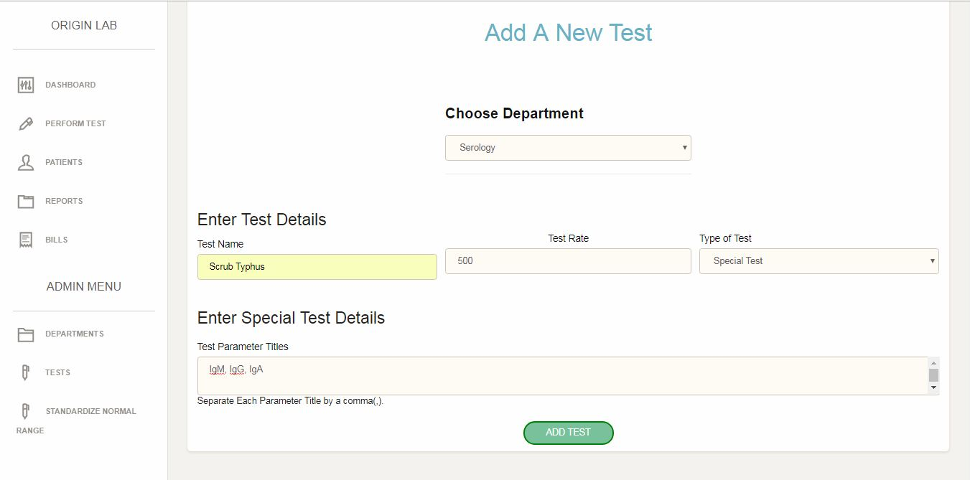

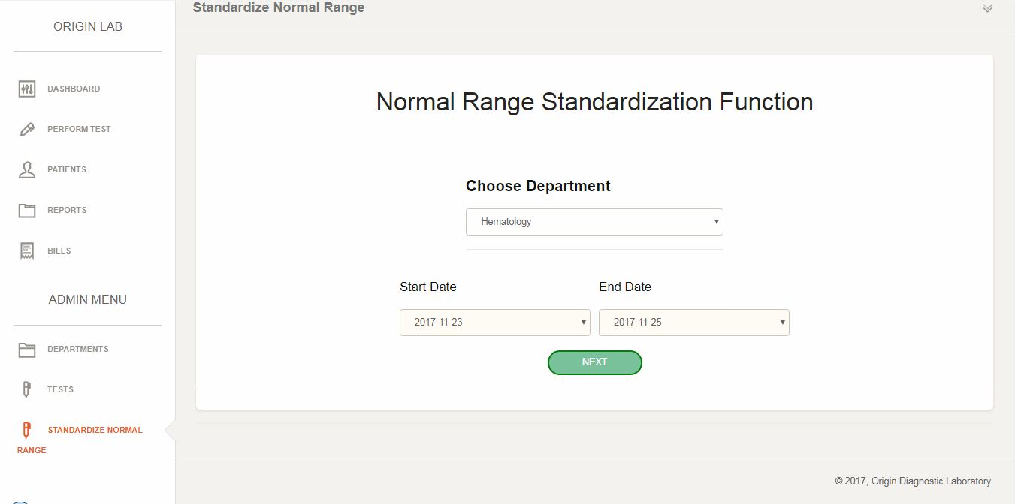11. Find Standard Normal Range – Step 1 Select Department and Date

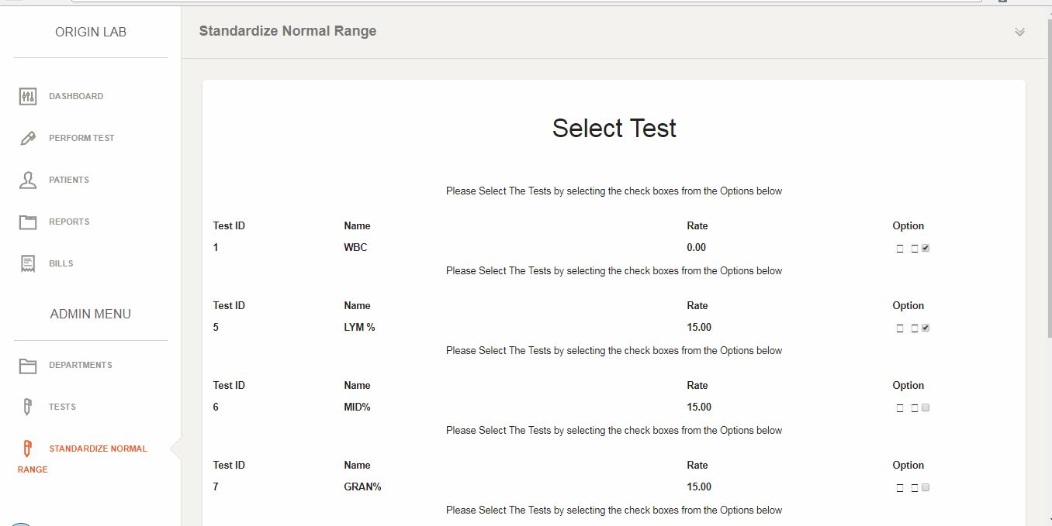11. Find Standard Normal Range – Step 2 Select Tests for the Department

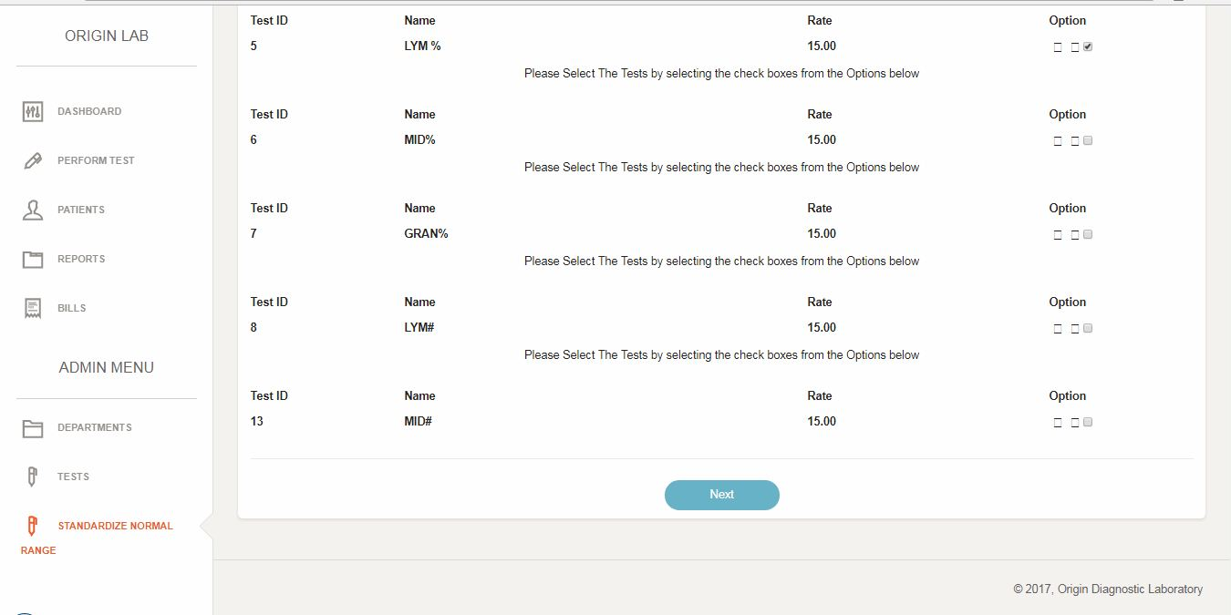

11. Find Standard Normal Range – Step 3 Calculations completed

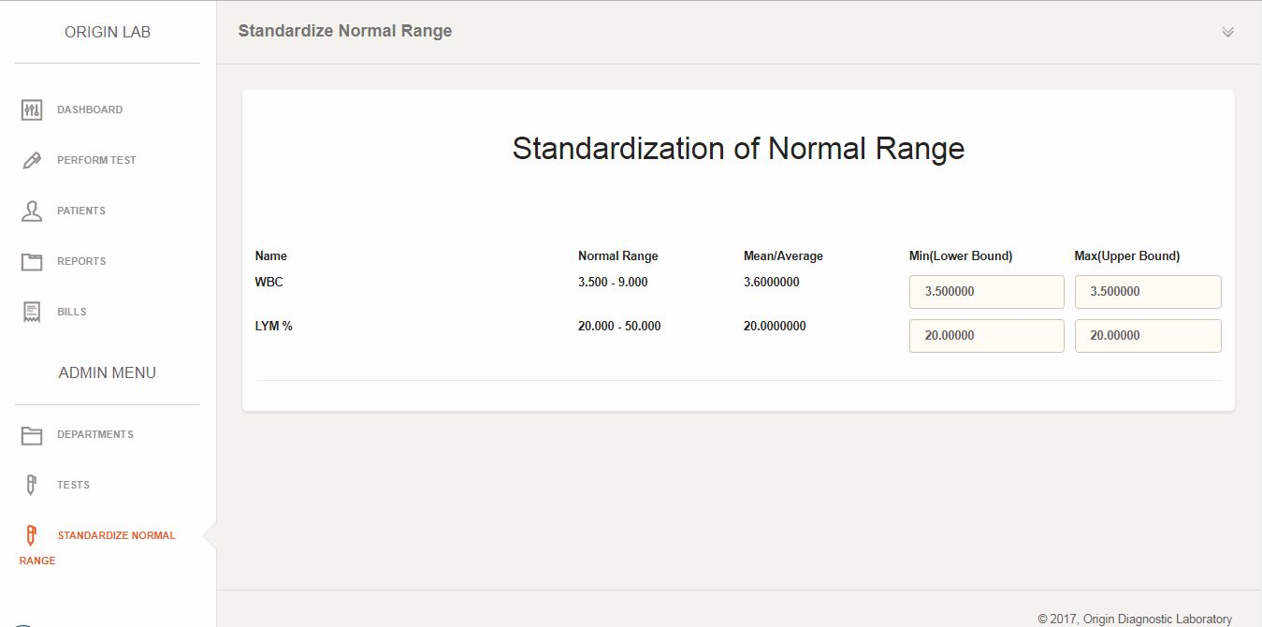

12. Perform Test and Generate Report – Step 1 Add a New Patient

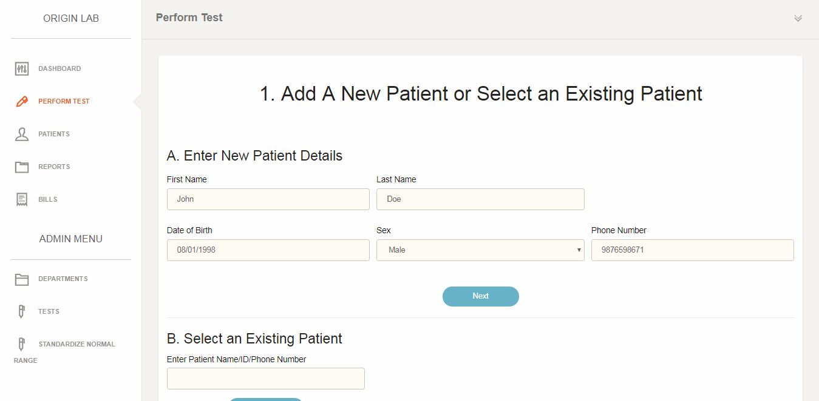

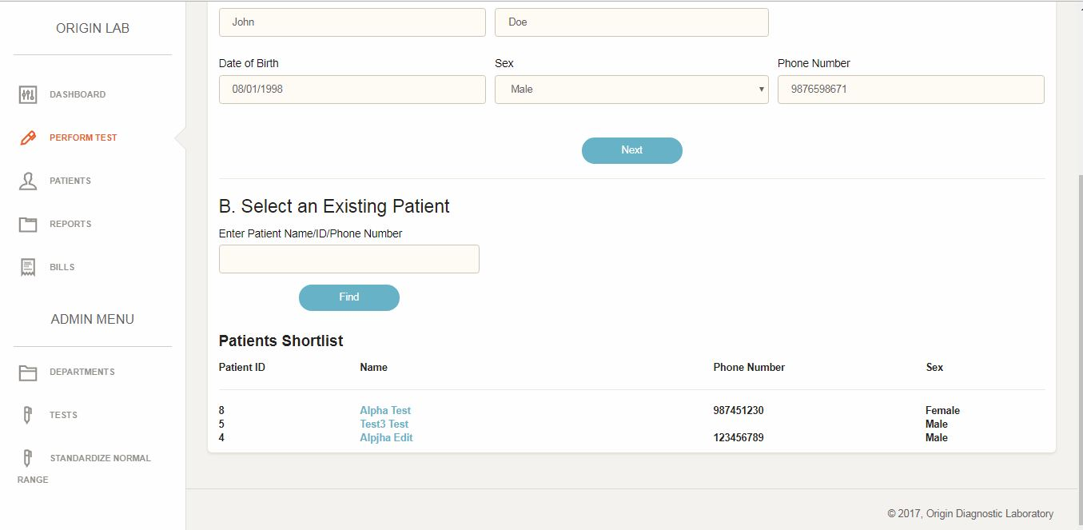

Step 2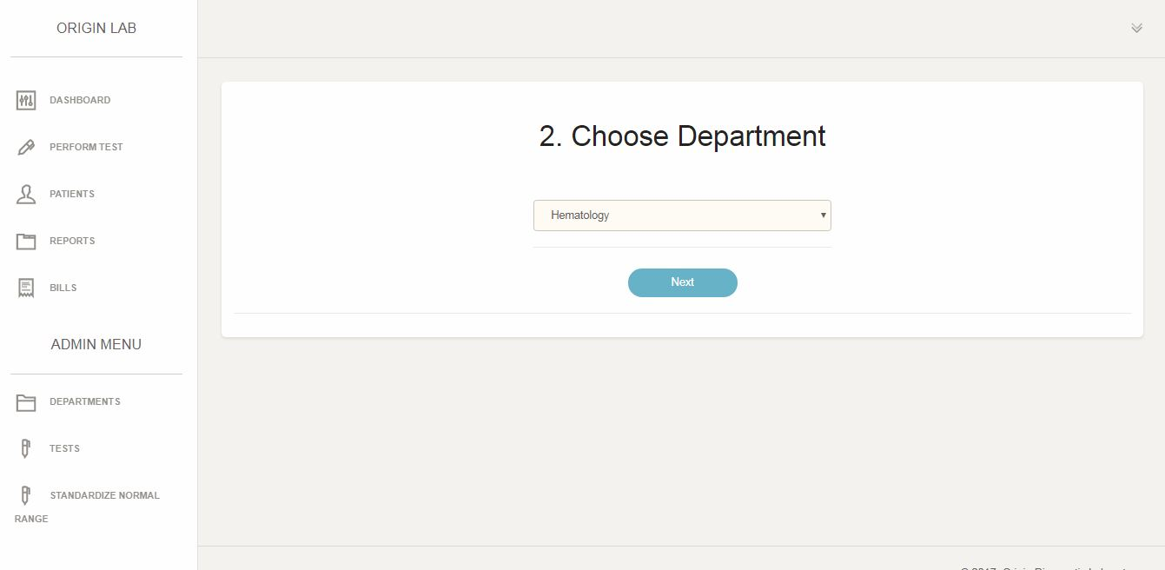

Step 3

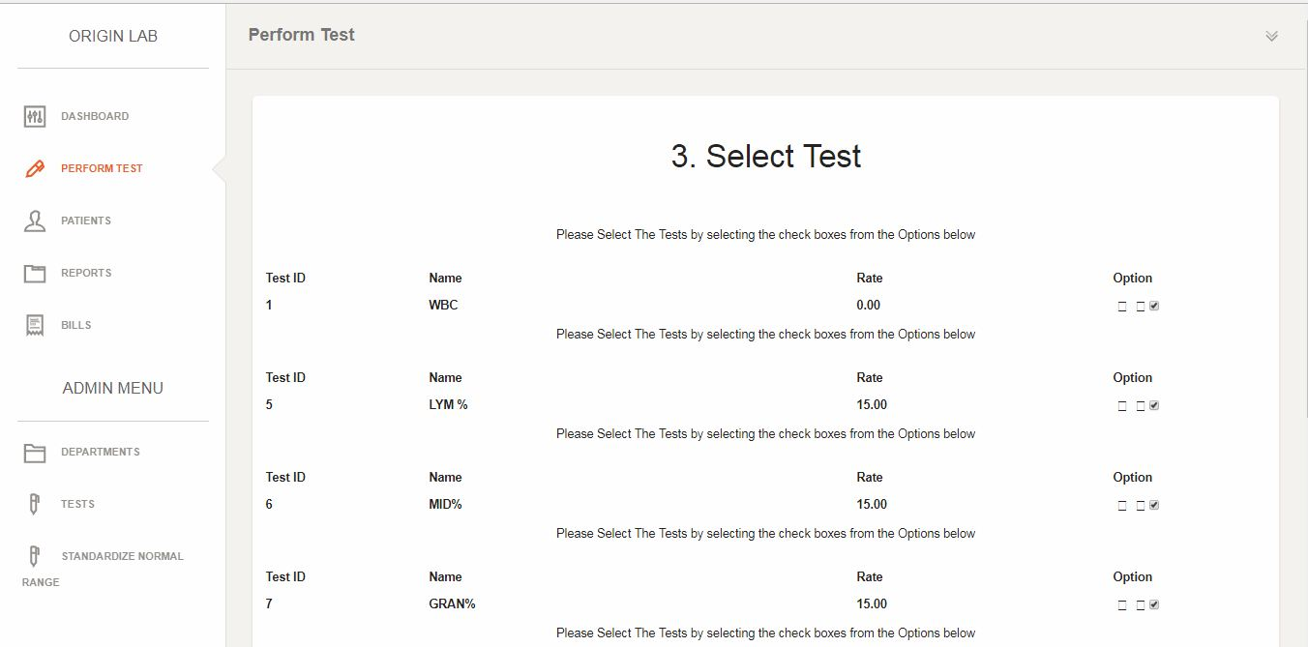

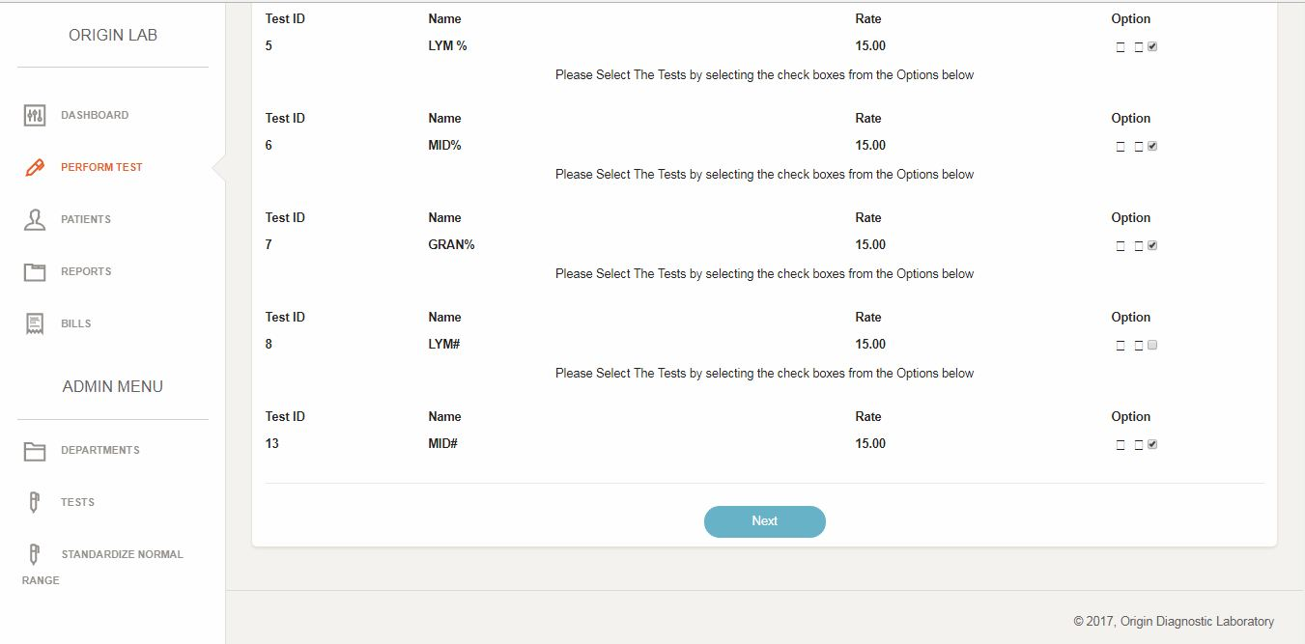

Step 4 Enter Test Results (for Normal Test)

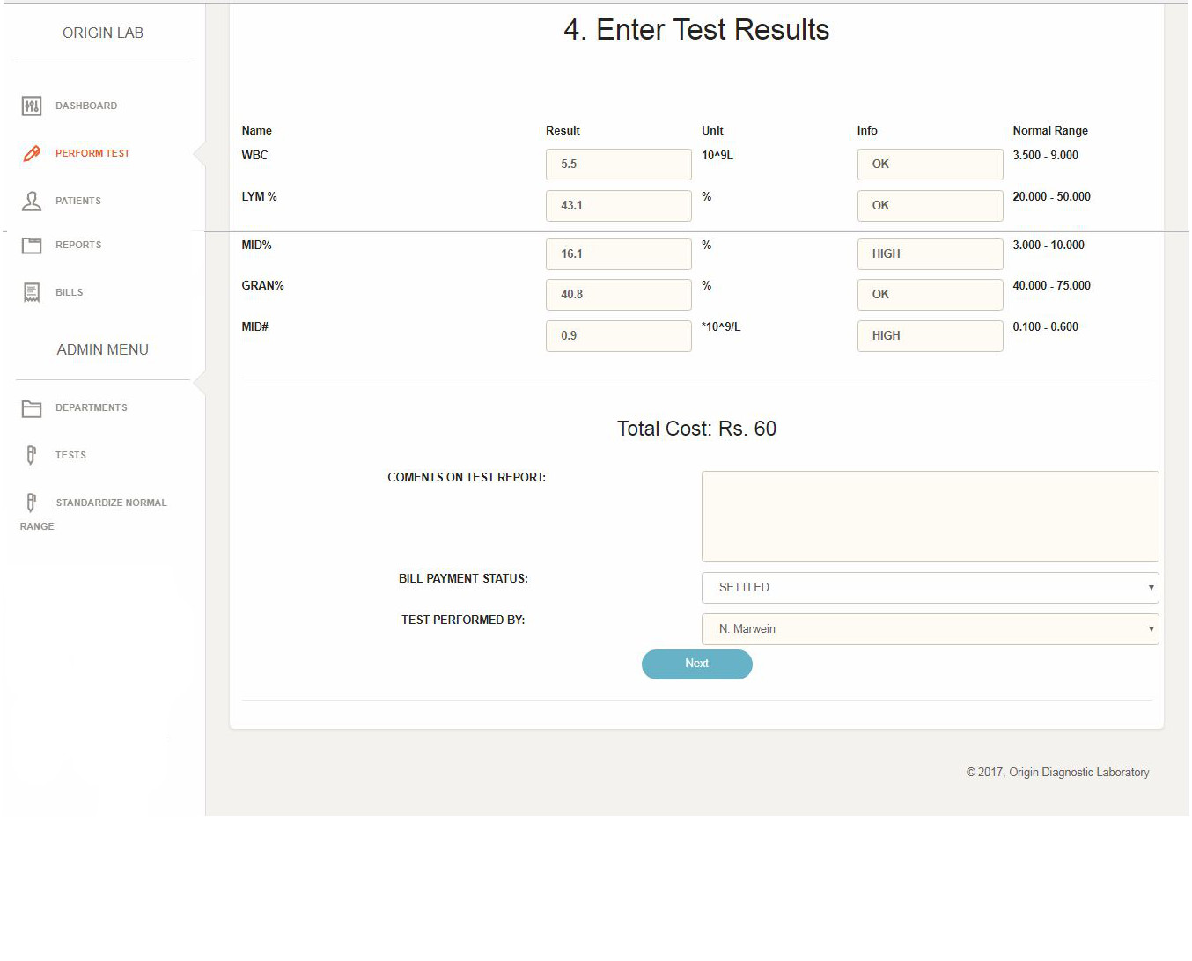

13. Report Generated

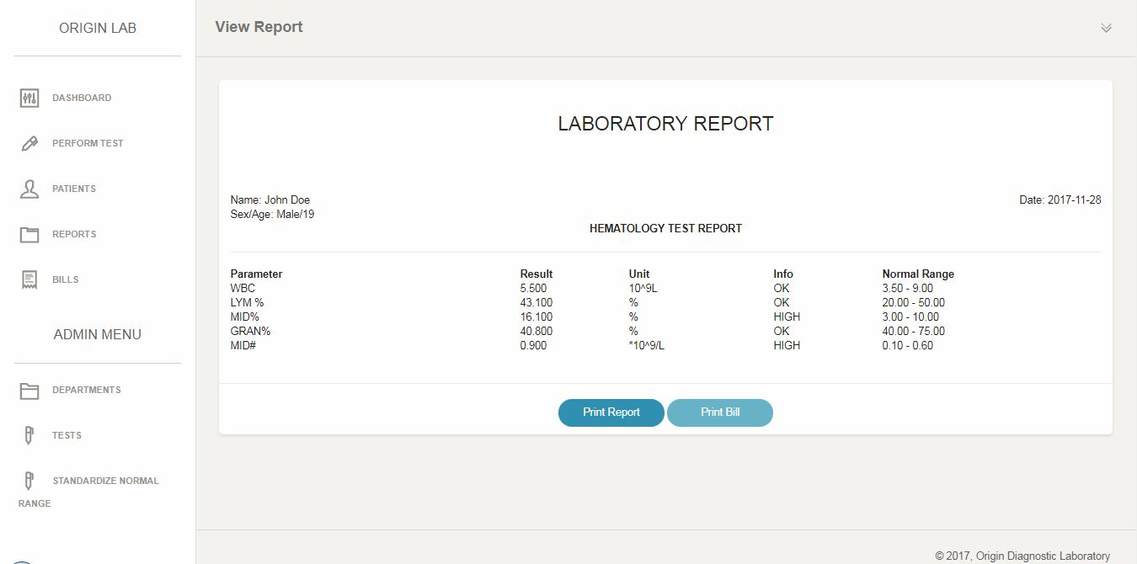

14. Print Report

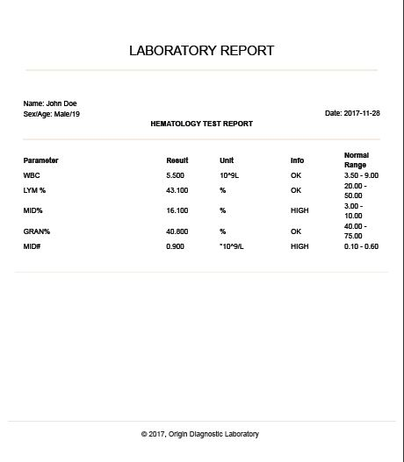

15. View Bill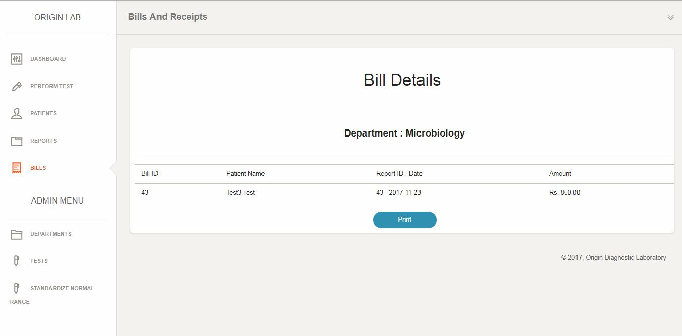

16. Print the bill

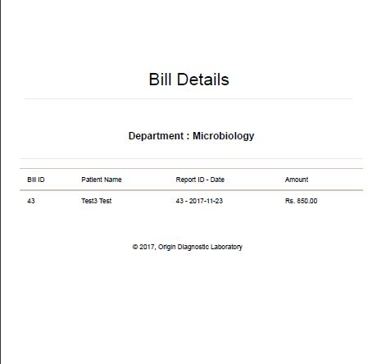

17. View Patient

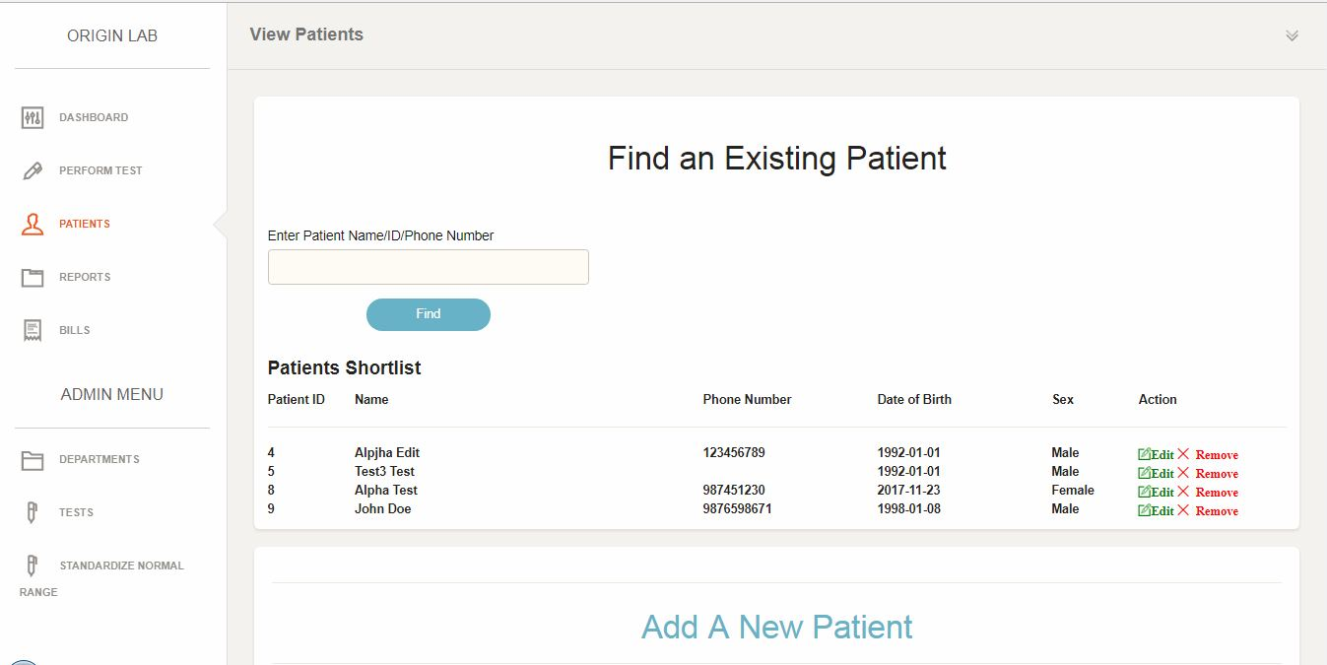

18. Edit Patient Details

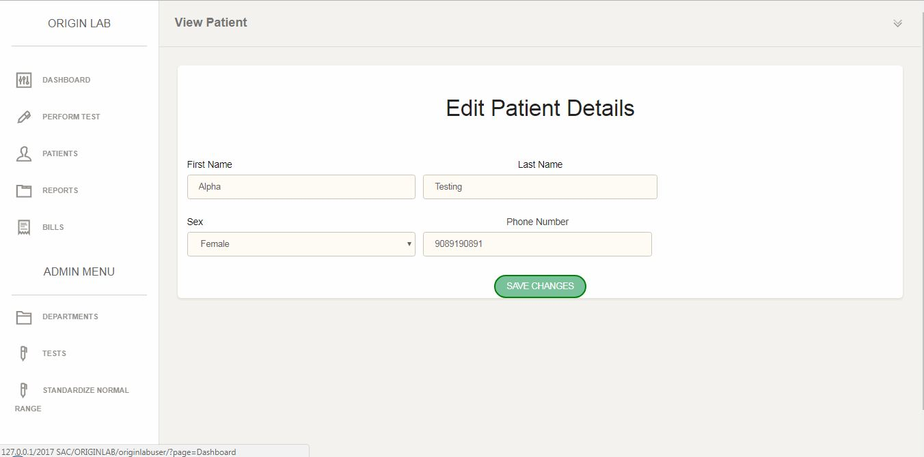

19. Entering Test Results for Culture Test (Step 4 and 5 of Perform Test)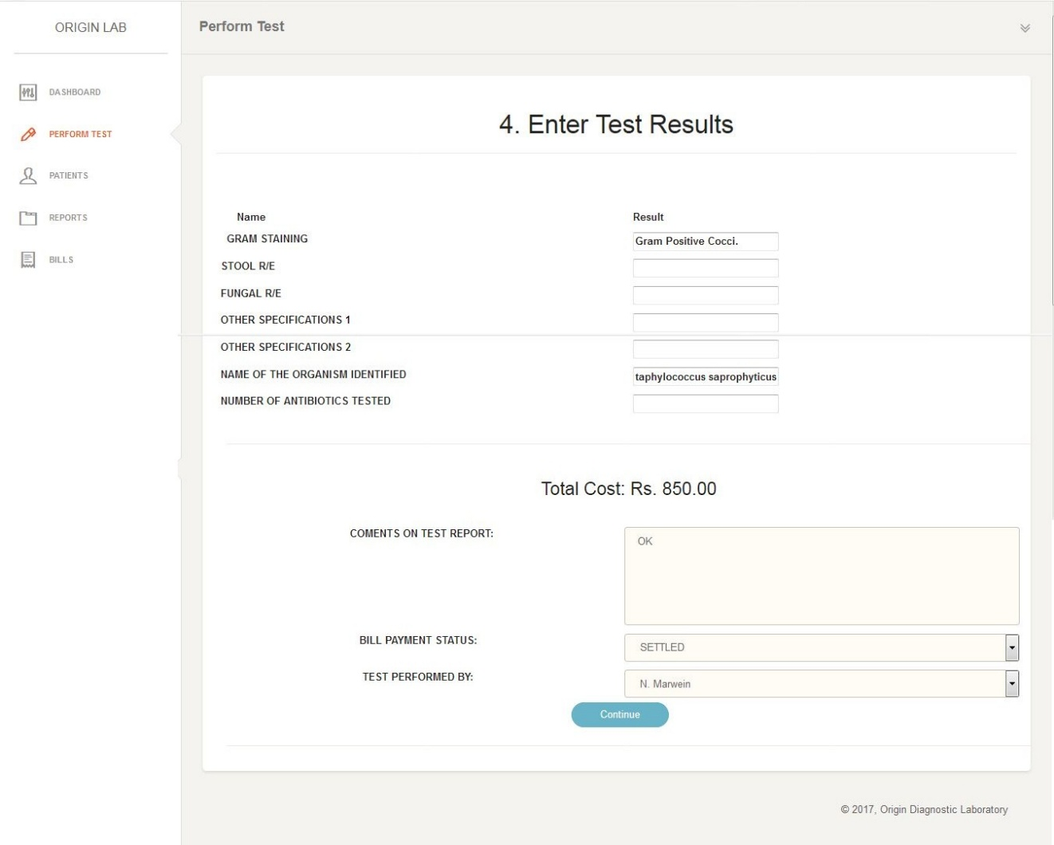

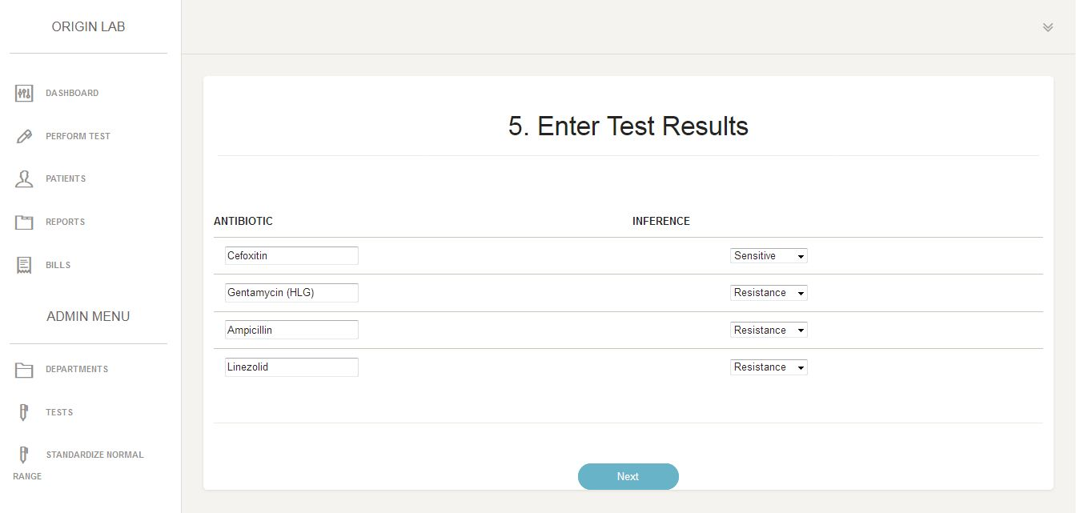

20. Report of Culture Test

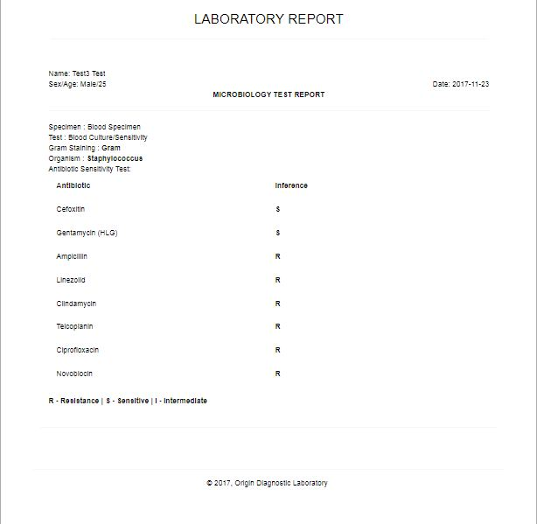

21. Report of Special Test

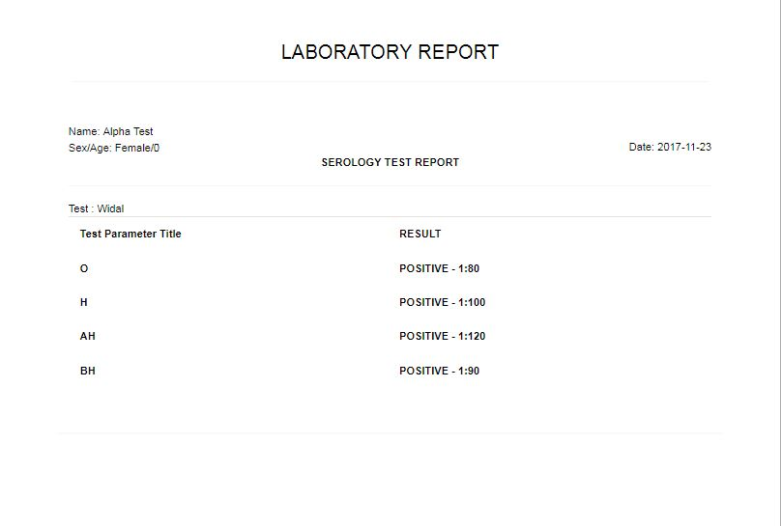

# SOURCE CODE

CD ATTACHMENT

**Read Me:**

The Application can be found inside the directory:

**CD DRIVE:\2017 SAC\**

Which should be copied to the server www/htdocs directory

**C:\wamp\www\**

The database file is called **originlab.sql** which can be found inside the CD

The database can be imported to the server using phpmyadmin which is available with the setup of wamp.

# **Future Enhancements**

The mini project has provided basic features for managing the reports and bills for the Organization, in order to make the application more usable and advance, future enhancement can be done to improve the proposed system.

A few enhancement that can be done in the future includes:

* Having Filters while viewing Patients, Reports and Bills, for viewing only specific details provided in the filter option, for example viewing list of Patients who where born during a specific year or Patients who belong to a particular state or region. Filters can be done on any of the attributes of the tables, as an example for Patient table we can filter by date of birth, gender, etc…
* To Add Users of the system, currently users like admin and staff users are added through sql statements. Another Administration Menu Item can be added which can allow an Administrator to Manage users including staff and other admins.
* To Display Monthly Reports of the laboratory in a Graphical Format. For example the number of new patients can be show in a line chart depicting the number of new patients for a particular month.
* To Export The Data to an Excel File.
* To allow patients to login, request for a particular test and print their test reports from home.
* To allow the staff to edit the test reports result.

# **Conclusion**

The proposed system aims in making the work flow of managing Patient’s Details, Reports more efficient and easy for the administrators. It also aims to ease and the computation of standardized values for the laboratory. As compared to the existing system the proposed system will make it easy for the administrators to manage all the details of the patients, the patient test reports and bills.

The system will also ease the calculation of Standard Normal Ranges of Normal Tests and reduce the time consuming computational task that was previously done manually.

# **Bibliography**

* <http://w3schools.com/>
* <http://php.net/>
* <https://www.tutorialspoint.com/php/>
* **PHP and MySQL by O’Reily**
* [**http://ecomputernotes.com/software-engineering/feasibilitystudy**](http://ecomputernotes.com/software-engineering/feasibilitystudy)
* **Software Engineering - A P R A C T I T I O N E R ’ S A P P R O A C H - Roger S. Pressman.**